**Elizabeth I**

**1558 - 1603**

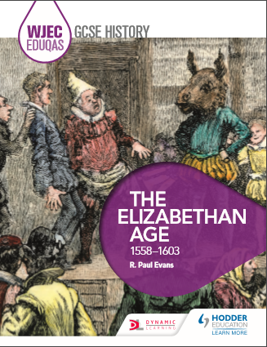

[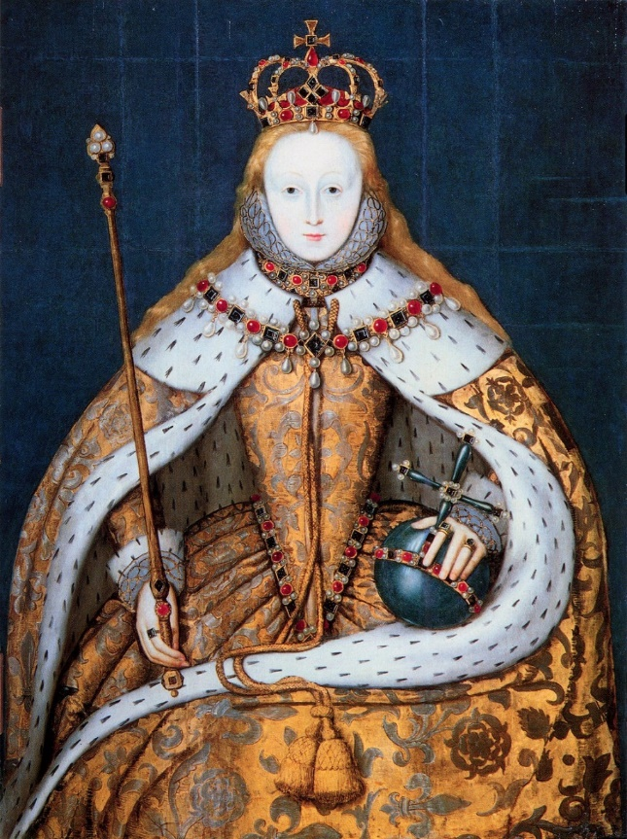](http://www.google.co.uk/url?sa=i&rct=j&q=&esrc=s&frm=1&source=images&cd=&cad=rja&uact=8&ved=0CAcQjRw&url=http://vintageprintable.com/vintage-printable-portraits-2/vintage-printable-portraits-2/portrait-painting-queen-elizabeth-i-coronation-robes/&ei=G8vlVPfWPMKwUcfkg8AN&psig=AFQjCNHLSzvsqOjOmLsT1IcEBwQjjB0BSQ&ust=1424432256984502)

**GCSE Revision Guide**

**Elizabethan government**

How successful was the government of Elizabeth I?

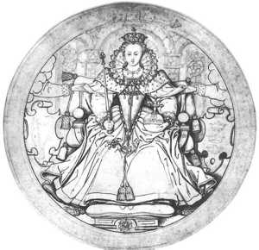

This section will include:

* The coronation and popularity of Elizabeth
* Royal Court
* Privy Council and councillors
* Local government
* The role of Parliament
* Taxation and freedom of speech

**Character and ability of Elizabeth**

When Elizabeth came to power she was seen as a more attractive, younger and successful queen than her sister Mary. For most of her childhood she has lived with a governess away from her father. Her governess, Kat Ashley, was well educated and devoted to Elizabeth. She supervised Elizabeth’s education which focussed on Geography, maths, language, sewing, dancing and riding. As a result Elizabeth had received a good education and spoke five languages fluently.

‘Elizabeth was quick-witted, clever and able to use feminine wiles to get her own way. Elizabeth could be as ruthless and calculating as any king before her but at the same time she was vain, sentimental and easily swayed by flattery. She liked to surround herself with attractive people and her portraits were carefully vetted to make sure that no physical flaws were ever revealed.’

**Her coronation and her popularity**

**[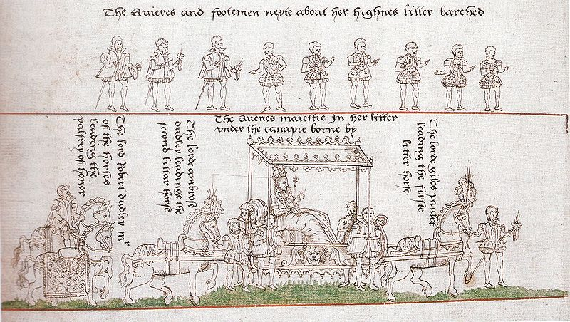](http://upload.wikimedia.org/wikipedia/commons/c/c4/Coronation_Procession_of_Elizabeth_I_of_England_1559.jpg)**On 17 November 1558 it is said that Princess Elizabeth was sitting under an oak tree at Hatfield House when a horseman appeared with the news that would change her life forever. Elizabeth, aged twenty-five, was now Queen of England. Mary I had died unpopular with her people. The country now looked to the young Queen for salvation. A new era was dawning, the age of Elizabeth I.

[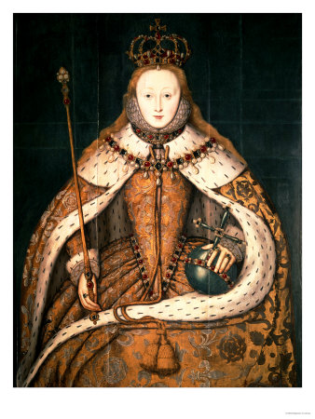](http://www.google.co.uk/url?sa=i&rct=j&q=&esrc=s&frm=1&source=images&cd=&cad=rja&uact=8&ved=0CAcQjRw&url=http://www.elizabethi.org/posters/queenelizabethi.html&ei=jmClVM9cjO9o7uiB8Ag&bvm=bv.82001339,d.d2s&psig=AFQjCNF154V3MqAruPJ4dtEVQjOAScawwA&ust=1420210285457900)**Features of her Coronation- 15th January 1559**

The celebrations for the Coronation, two months later, were spectacular.

* As Elizabeth walked along the carpet laid out for her journey to Westminster Abbey, the crowds rushed forward to cut out pieces as souvenirs.
* Elizabeth made sure that everyone - down to the lowliest beggar - played a part, pausing to listen to congratulations from ordinary people on the street.
* She knew that, in political terms, she needed their support but she also felt a deep sense of responsibility for their welfare.

**The stages of the coronation were:**

Coronation portrait of Elizabeth I

The full proceedings of a coronation in medieval times, and up to Elizabeth I’s and beyond, fell into four parts.

1. Elizabeth took control of the Tower of London: the significance of that was to take control of London.
2. Elizabeth then stayed in Westminster on the eve of the coronation.
3. The next day she attended the coronation itself in Westminster Abbey with a huge the procession to it.
4. There was then a huge banquet in Westminster Hall where they celebrated the coronation of the new Queen.

The purpose of the coronation was not only to show she was now in charge but to also show her devotion to her people who were both the Protestant and Catholic.

**The main features of Elizabethan government**

**Life in the Royal Court**

Look at the diagram on the next page and make a list of the features of life at Court



In Elizabethan times Government operated on two levels: Central and local government

Alongside this structure the Queen had her own court which was the centre of power, ritual and celebration. A place in court was seen as essential for success since political advancement depended on a system of PATRONAGE which was ultimately controlled by the Queen.

**5 Ps (+JPs) of how Elizabeth governed England**

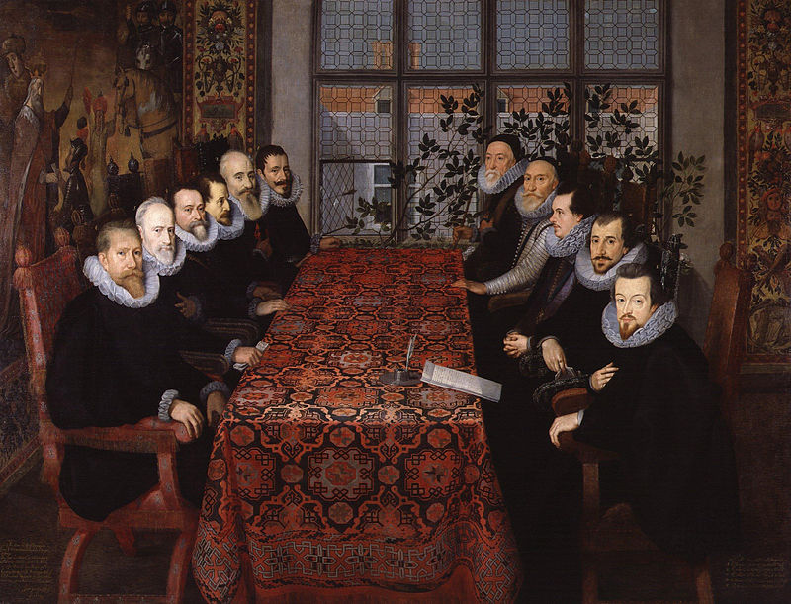**Privy Council-** a body of advisers chosen by the Queen who also had responsibility for carrying out royal decisions.

Dealt with:

* Questions of state –
* Army/Navy
* Diplomacy
* Clergy
* Sheriffs, Local Officials, Justices of the Peace
* Were between 12 and 20 in number

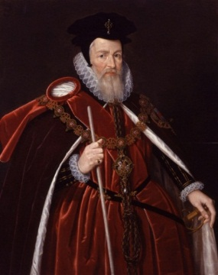**Prominent Ministers-Cecil, Leicester, Walsingham;**

**Francis Walsingham**

* Elizabeth’s spymaster- responsible for her security and safety.
* Involved in discovering the Catholic Plots against Elizabeth.
* Very strong protestant- this caused some issues with Elizabeth but she respected him greatly.

**William Cecil- Lord Burghley**

* 1558- Made secretary of State, a position which he held until his death in 1598.
* Given title Lord Burghley in 1571.
* Elizabeth’s most important Councillor

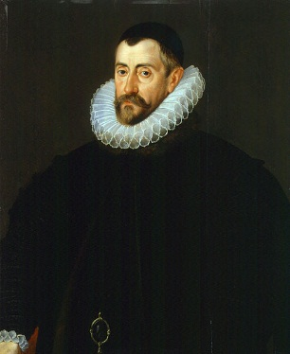

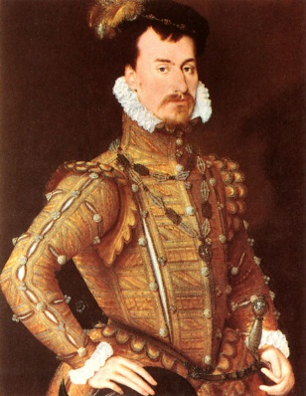

**Robert Dudley- Earl of Leicester**

* Favourite of Elizabeth’s who she was believed to be romantically attached to.
* 1564- Made Earl of Leicester
* He was given large estates and licences.
* Did not get on very well with Cecil
* 1585- Made Lieutenant General of the army in the Netherlands

**Patronage**- rewarding of supporters with offices, titles and wealth (see ministers above e.g. Dudley)

One way for Elizabeth to get people on her side was by ***patronage***. Many rewards were at the queen's command. Patronage took the form of:

Titles, bishoprics, monopoly rights, cheap leases of royal lands.

**Presence**- Presence in Court and how she made her presence felt.

Elizabeth wore elaborate dresses and appointed a number of prominent ministers who would follow out her orders. Court was the place where decisions were made and where she would meet with and impress foreign ministers and councillors. Presence at court was essential if you wanted to be a significant part of Elizabeth’s government.

**Purse-** How the country’s money was collected, controlled and used.

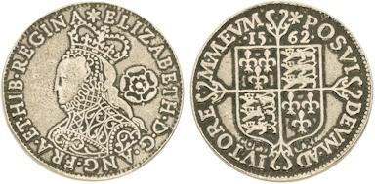This included:

* Taxes
* Royal Revenue (money) (income/expenditure)
* Elizabeth cut back spending severely
* Decisions were made by the Queen and Privy Council and carried out by the exchequer.
* Wherever possible the government used unpaid officials such as JPs to help out.
* There were few salaried officials and where they were paid salaries were low.

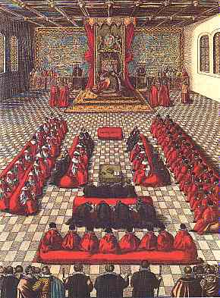

**Parliament-** Main functions included passing laws and raising taxes. Not as important as today and not the most important element of government at the time.

* Queen cannot control elections therefore she faced opposition, even criticism.
* Only summons Parliament *TEN* times.
* However, she appoints Speaker of House to control debates
* Threatens MPs, no patronage.

****Justices of Peace**- Responsible for enforcing laws on a local level, hearing cases and determining sentences. A bit like a magistrate today. They met on average four times per year.

Their powers included:

1. Enforcing laws
2. Investigating people who may have broken the law
3. Hearing cases in local courts
4. Deciding on sentences
5. Administering the Poor Law
6. Controlling sheriffs
7. Controlling licensed ale houses

The changing role of Parliament

Read the statements. Tick them if they suggest Parliament had power, cross them if they suggest they did not.

|  |  |
| --- | --- |
| In the 25 years leading up to Elizabeth’s leadership Parliament’s power had grown. |  |
| It had the opportunity to raise concerns and further its own interests in a state where a monarch needed money. |  |
| It was not an integral part of government by 1558 (this was the role of the Privy Council and Elizabeth. |  |
| The monarch decided how often they should meet and for how long. |  |
| The partnership between the monarch and Parliament was understood to be the most powerful authority in the country. |  |
| The right to issue new policies remained with the monarch. |  |
| The monarch determined when it was summoned (called) and dissolved (sent away) |  |
| The speaker was nominated by the Privy Council |  |
| Parliament played a significant role in granting taxation |  |
| It had helped put in place the religious changes. |  |
| It was usually only used to approve extraordinary taxation and new laws. |  |
| It did not have enough power to make the granting of new taxes dependent on the withdrawal of an unpopular royal policy |  |
| They were only summoned 13 times during Elizabeth’s 45 year reign |  |

The main topics discussed at Parliament were:

* + Requests for money by Elizabeth
  + Demands for freedom of speech from Parliament
  + Conversation about affairs of the state (succession, religion, marriage)

**Lifestyles of rich and poor**

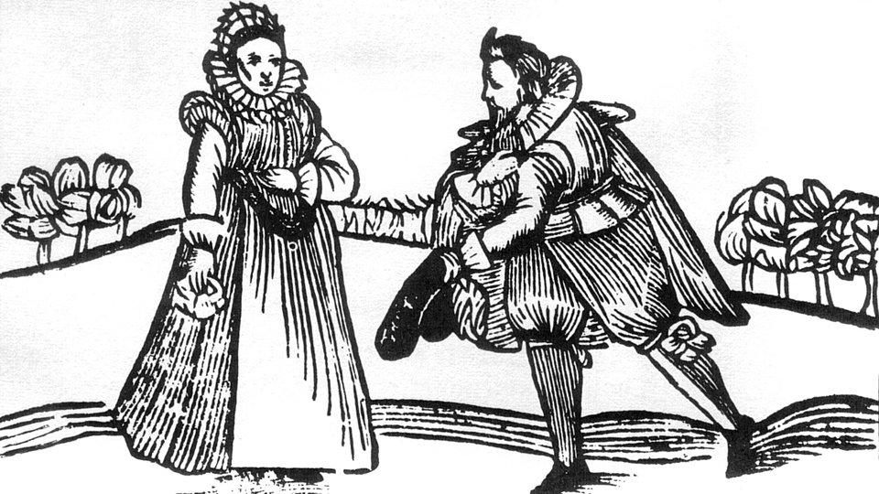How did life differ for the rich and poor in Elizabethan times?

This section will include:

* Contrasting lifestyles of rich and poor
* Homes and fashion
* Causes of poverty
* Issue of unemployment and vagrancy
* Government legislation including the 1601 Poor Law

**Lifestyles of rich and poor**

During the reign of Elizabeth I, about eight out of ten people lived in villages in the countryside.

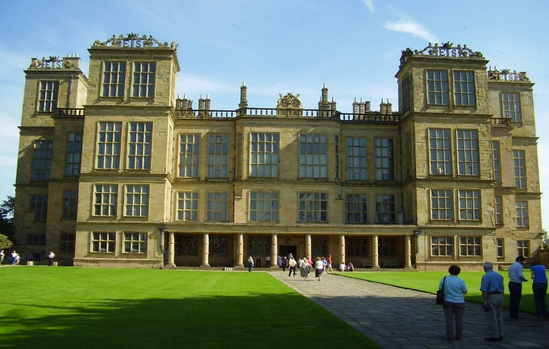Most of these people worked on farms for rich landowners because few people could afford to own land. They would sow crops and harvest them, as well as looking after animals such as cows and sheep.

The growth of sheep farming caused unemployment and hardship.

During Elizabeth’s reign some people became much richer. This was because of:

* Wealth from trade in New World
* Closing of the monasteries by Henry VIII
* Vast estates e.g. Hardwick Hall (see picture)

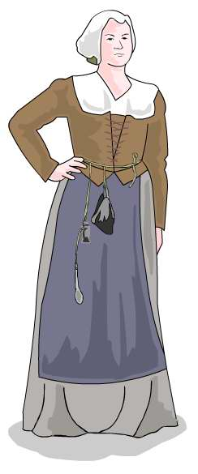**Tudor clothing**

**Poor** people wore simple, loose-fitting clothes made from woollen cloth. Most men wore trousers made from wool and a tunic which came down to just above their knee. Women wore a dress of wool that went down to the ground. They often wore an apron over this and a cloth bonnet on their heads.

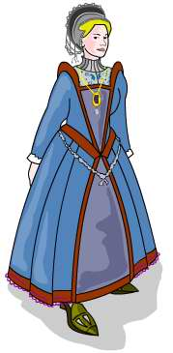**Rich** people could afford clothing made of fine wool, linen or silk. Their clothes were decorated with jewels and embroidered with gold thread.

No rich person felt properly dressed to impress unless he or she was wearing a ruff. Like so many Tudor clothes, it gave a strong signal about the wealth and importance of the person wearing it.

**Rich ladies** wore padded skirts held up with loops. Over these went bodices and colourful floor-length gowns.

**Rich men** wore white silk shirts, frilled at the neck and wrists. Over this they wore a **doublet** (a bit like a tight-fitting jacket), and close-fitting striped trousers (called **hose**).

Everyone wore their hair shoulder length

**The problem of poverty**

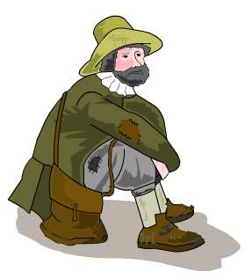In Elizabethan times there a lot of poverty because:

* There was no unemployment pay or sickness benefit at the time.
* There were also no pensions for old people.
* If people didn’t work they would starve
* Most people who could not find work became tramps and begged for food. The Tudors named these people vagabonds.
* During the 16th century the situation got worse because Henry VIII shut down the monasteries which had looked after the poor and sick.
* Many landowners stopped growing crops and turned to sheep farming as there was a great demand for wool. This used less workers and meant there were fewer jobs available!
* Prices were going up faster than wages and people discovered that their pay did not buy as much as it used to; the poor were getting poorer.

By the middle of Elizabeth’s reign up to 1/3 of all people were considered to be poor.

**How did Elizabeth deal with the problems of poor people and beggars**?

The government took two very different approaches to the poor. Firstly it introduced harsh punishments like whipping and branding with a V to deter people from becoming beggars. Secondly, parishes (local areas based on a church catchment's area) were made more responsible for their poor.

Parishes now had to appoint people called **beadles** to identify who was really poor – the **deserving poor/impotent poor** – and who was a crank, vagabond or a **sturdy beggar/able-bodied poor**, a person who was able to work but didn’t. Beadles could expel (get rid of) vagabonds from the parish or punish them. This system was intended to make each parish look after its own poor, to replace the monasteries which had previously looked after the poor. Each parish collected money – the **poor rate** – to give to the deserving poor. This system lasted, with few changes, until 1834.

**1601 Poor Law**

By the late 1500s the government had realised there was not enough charity to help the poor or employment opportunities for everyone. They also began to realise not all able-bodied poor were idle (lazy) and that some who wanted to work were unable to do so. The Poor Law of 1601 had the following principles:

* The administration of poor relief was the responsibility of JPs and church wardens
* JPs had to decide who was ‘able bodied’ and who was ‘needy’
* JPs appointed overseers to give orphans apprenticeships
* The unable poor (disabled/ill/elderly) were to be looked after, if necessary, in specially built accommodation (alms houses)
* The able bodied poor should be given materials and the opportunity to work at a craft like spinning/weaving
* Able bodied poor who refused to work should be punished and confined
* The cost of this would be met by a *poor rate* which was paid by people who worked (like a tax)
* Begging was forbidden- if you were found begging you could be returned to the parish you were born in and sent to a House of Correction (Bridewell)

BUT- The problem did not go away; there were still a large number of poor people.

**Popular entertainment**

What were the most popular types of entertainment in Elizabethan times?

This section will include:

* The importance of popular entertainment
* Cruel sports
* Entertainment enjoyed by the rich
* The Elizabethan theatre
* Design and plays
* Attitudes towards the theatre

How did Tudor people have fun?

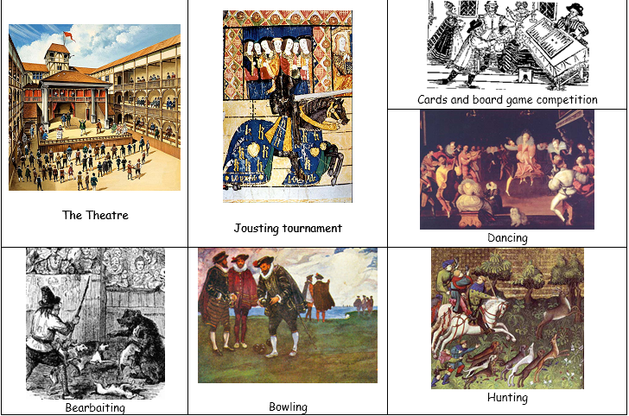

Entertainment in Tudor London was rich and varied. There were many taverns for people to drink in, and outside many of these there would be ‘entertainment’ such as cock-fighting (where male chickens fought each other) or bear-baiting.

Bear baiting involved chaining a bear to a post and then letting dogs attack it. People bet on how long the bear could last.

Public executions were always well attended, and seen by Londoners as a great day out.

One of the most often visited places was St Bethlehem’s Hospital, called **Bedlam** for short, where people paid to go and see the insane patients inside.

Different types of entertainment also included:

* Jesters - A fool or buffoon at Elizabethan courts
* Mummers - A masked or costumed merrymaker or dancer especially at a festival
* Minstrels - Travelling musician who sang of legends (declined in the Elizabethan era)
* Troubadours - Travelling musician who sang of courtly love (declined in the Elizabethan era)
* Acting Troupes - Travelling actors
* Jugglers - Also used tricks, deception, or fraud

**The Globe**

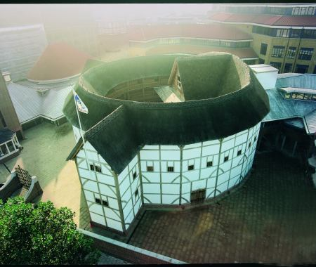A theatre made from beams and wood from another theatre called ‘The Theatre’ which had been owned by Richard Burbage’s father (James Burbage). Richard Burbage became a famous actor in William Shakespeare’s time. The Globe was the first theatre inside the city walls and opened in 1599. The first ever public theatre was opened in 1576 outside the city walls in Shoreditch, to the north of the city. They were not allowed in the city before this as the Puritans would not allow this.

**Why did people go to the Theatre?**

* From the 1570s Elizabethan Court had showed real enthusiasm for plays and, as a result, companies of players were formed under the patronage of various noble men.
* From 1572 onwards actors had to secure the patronage from a baron to gain a licence to perform. This gave the government some control over what was performed.
* The real development came when permanent theatre were established in London under royal licence. The first two *The Theatre* and *The Curtain* opened in Shoreditch in 1576 & 1577. They gave daily performances, except on Sundays, by a leading company of players.
* Soon after various other theatres developed including ‘The Rose’ (1594) and ‘The Swan’ (1595).
* The theatre was cheap entertainment and could accommodate people of all classes.

**Key actors/playwrights**

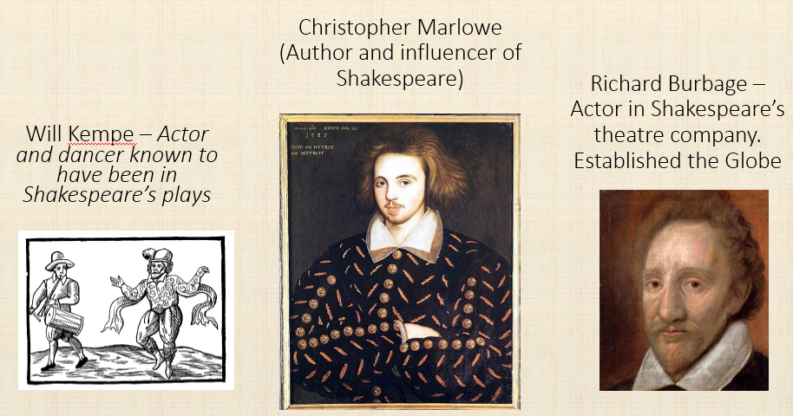

Opposition to the theatre mainly came from Puritans who thought it was too indulgent and distracted from their worship. Puritan opposition meant that initially theatres could only be outside the city walls.

**The problem of religion**

How successfully did Elizabeth deal with the problem of religion?

This section will include:

* Religious problems in 1559
* Aims of the Religious Settlement
* The “Middle Way”
* Acts of Supremacy and Uniformity
* Reactions to the settlement

**The 1559 Religious Settlement**

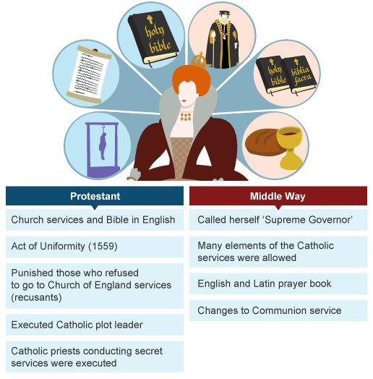

**Act of Supremacy and Uniformity**

* Under a traditional Catholic country the Pope was head of the Church
* Under a Protestant country the monarch (King/Queen) was head of the Church
* In 1559 Parliament was called to decide the Queen’s authority over the church and passed the ‘Act of Supremacy’.
* This made Elizabeth ‘Governor’ of the Church of England
* At the same time Parliament also passed the ‘Act of Uniformity’ which said how church services should be run.
* These two acts (laws) made up the religious settlement

Changes in Wales were the same as in England except the prayer book and bible were translated into Welsh. Church services were also in Welsh. This was because a lot of Welsh people were Catholic and Elizabeth wanted them to follow her new Anglican (Elizabethan) church. Most Welsh people at this time did not speak English and therefore they could not use the English prayer book and bible. Keep your eyes peeled later for famous Welsh Puritans and Catholics who were punished by Elizabeth!

|  |  |  |  |
| --- | --- | --- | --- |
| Religious Settlement- The Middle Way | P | B | C |
| “ The Queen would rule as Supreme Governor supported by the bishops” |  |  |  |
| Some church courts would remain. |  |  |  |
| There should be limits on what preachers could say. |  |  |  |
| There should be no Mass. |  |  |  |
| Church services and the Prayer Book should be in English. |  |  |  |
| Saints should receive no special prayers. |  |  |  |
| Churches should be decorated and some ceremonies should be allowed. |  |  |  |
| Bright robes should be allowed. |  |  |  |

**Elizabeth's attitude to Catholics**

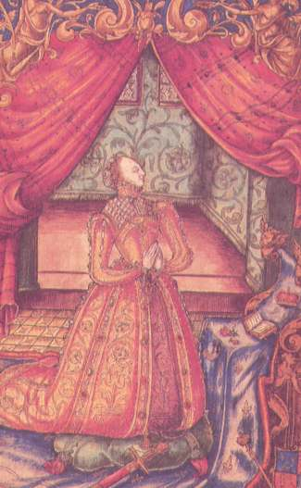Elizabeth initially took a fairly lenient (kind) approach towards Catholics who did not follow her middle way. Some punishments included:

* Catholics had to pay a 1 shilling fine if they did not go to church on Sundays or other important days. (This was not very much for a rich Catholic).
* Priests/people with positions in government who would not take the Oath of Supremacy lost those positions.
* If you continued to follow the Pope instead of Elizabeth you would lose property for the first offence, your goods and freedom for the second and would be executed for the third.
* If a Cleric (church man) did not follow the new prayer book they could be punished with fines or imprisonment.

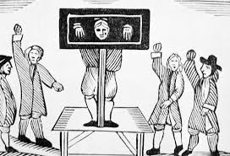**Recusants**

All those who **refused to take the ‘Oath of Supremacy’** (accepting Elizabeth as governor of the church) and the terms of the Act of Uniformity were known as **Recusants**. They could be found guilty of high treason.

1559: The Royal Injunctions was drafted by Cecil to ensure the Religious Settlement was followed by churches. One of its’ orders was to ‘report recusants to the privy council or JPs’. 125 commissioners were appointed to visit churches throughout the country and make sure Elizabeth’s orders were carried out.

**Excommunication**

* 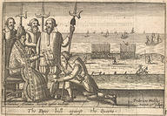When Elizabeth first took over the Pope avoided challenging her about her religious changes.
* He also did not tell Catholics to stop going to Anglican (Elizabeth’s) church services until 1562 and then only did so because it was requested by some English Catholics.
* The Pope was also initially keen to keep relationships between different countries good and at this time Philip II of Spain wanted to keep his friendship with England so persuaded him not to excommunicate Elizabeth initially.
* In 1566 there was a new Pope, Pius V. He took a harsher stance against Elizabeth and excommunicated her from the Catholic Church.

**Execution of Richard Gwyn- 1584**

[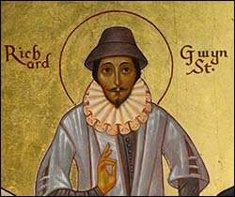](http://www.google.co.uk/url?sa=i&rct=j&q=&esrc=s&frm=1&source=images&cd=&cad=rja&uact=8&ved=0CAcQjRw&url=http://historypoints.org/index.php?page=st-mary-s-cathedral-wrexham&ei=V8HbVNeOGMP6aLf3gNgD&bvm=bv.85761416,d.d2s&psig=AFQjCNHk-5C2jCL_H1HVXHrZri_FmgAbTA&ust=1423774402922077)

Riichard Gwyn, executed on 15 October 1584 for following the Catholic faith and refusing to recognise the Anglican Church (the Elizabethan Church). He was the first Welsh Catholic to be executed for his beliefs during the reign of Queen Elizabeth 1st.

Because of his outspoken criticism of the Elizabethan Reformation and Church, Gwyn was forced to move house – and his school – many times in order to avoid fines and/or imprisonment. Despite the regular moves, in 1579 he was arrested by the vicar of Wrexham. He managed to escape and was on the run for the next 18 months. Then he was recaptured and held in a number of prisons for the next four years before being executed in 1584. He was found guilty and sentenced to be hung, drawn and quartered.

The sentence was duly carried out at the animal market in Wrexham on 15 October 1584. Gwyn showed rare courage and the executioner even pulled on his shackled legs in order to kill him more quickly and so ease his suffering. It did not work. Despite seeming to be dead, Gwyn revived just as the disembowelling began – he remained conscious until he was finally beheaded.

**The Catholic threat**

Why were Catholics such a serious threat to Elizabeth?

This section will include:

* Early toleration
* Excommunication in 1570
* Recusancy
* Rebellion of Northern Earls
* Catholic Plots – Ridolfi, Throchmorton, Babington
* Role of Mary Queen of Scots

**Catholic Plots**

**The Northern Rebellion- 1569**

[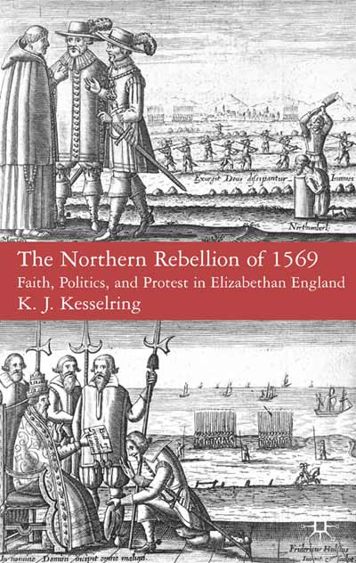](http://www.google.co.uk/url?sa=i&rct=j&q=&esrc=s&frm=1&source=images&cd=&cad=rja&uact=8&ved=0CAcQjRw&url=http://www.palgrave.com/page/detail/the-northern-rebellion-of-1569-kj-kesselring/?K=9780230553194&ei=F_3lVPCqEdTfaqaegpgM&psig=AFQjCNEDs4ANhfqAfnl_MujTOHpde_O4fg&ust=1424445064825739)This plot was triggered by Mary Queen of Scots arrival to England in 1568. The plan began as a conspiracy at court to marry the Duke of Norfolk to Mary which would make her heir to the English throne. The aim was then to overthrow Elizabeth and Cecil and restore Catholicism to England. The plan was initially supported by two of Elizabeth’s councillors; the Earl of Leicester and Sir Nicholas Throckmorton. In September 1569 Leicester confessed everything to Elizabeth and Norfolk fled from court. The plot was then taken on by the Earls of Northumberland and Westmoreland who got ready to march south and restore Catholicism. They struggled to get support from other catholic gentry and were defeated by Government forces. Spain initially promised help but did not actually send anyone to support the Northern Earls.

Elizabeth punished Norfolk with a brief spell in the Tower of London, and although the Privy Council wanted him executed, she did not do this. Northumberland and Westmoreland fled to Scotland.

**The Ridolfi Plot- 1571**

Following Elizabeth’s excommunication (cutting off) from the Catholic Church an uprising was planned to replace Elizabeth with Mary Queen of Scots who would be married to the Duke of Norfolk. Roberto de Ridolfi (an Italian merchant with connections in many European courts) planned to use his connections with the Spanish army and Philip of Spain to help with the take-over of power. Cecil discovered the plot and Norfolk’s role was exposed. The Privy Council persuaded Elizabeth to call Parliament with the aim of getting agreement to execute Norfolk and Mary Queen of Scots. Parliament brought two bills one asking for Mary’s execution and the other barring her from succession. A law was also passed making it high treason to try and take Elizabeth’s title of Queen.

Elizabeth delayed signing Mary’s death warrant twice but finally agreed to Norfolk’s execution to keep the House of Commons happy. Norfolk was trialled in 1572 and argued he should not be executed because he was an earl. Elizabeth had Norfolk executed.

**[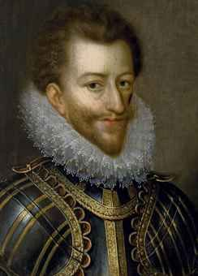](http://www.christies.com/lotfinderimages/D54046/ecole_francaise_du_xvieme_siecle_portrait_dhenri_de_lorraine_duc_de_gu_d5404677h.jpg)The Throckmorton Plot- 1583**

Plans were made for French Catholic forces, backed by money from Spain and the Pope to invade England, free Mary Queen of Scots and start a Catholic uprising. Throckmorton was responsible for the negotiations between Mary and the Spanish ambassador (De Mendoza). The plot also involved some Catholic Priests.

Elizabeth had Throckmorton tortured and executed. In 1585 Parliament passed an act which said it was treason to become a priest and the death penalty could be used for those who helped priests in any way.

[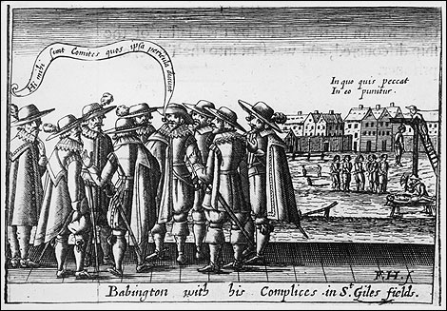](https://www.google.co.uk/url?sa=i&rct=j&q=&esrc=s&frm=1&source=images&cd=&cad=rja&uact=8&ved=0CAcQjRw&url=https://mathewlyons.wordpress.com/2011/12/07/catholic-treason-in-elizabethan-england-and-the-psychology-of-espionage-and-terror/&ei=vfvlVIjrENjkatWWgfAD&bvm=bv.85970519,d.d2s&psig=AFQjCNH7Ngi3jCFB6fJln1h0COE3JaiOOA&ust=1424444729511551)**The Babington Plot- 1586**

Mary had been liaising with a group of Catholics led by a man called Antony Babington. A letter, supposedly dictated by Mary and agreeing to Antony Babington’s plot to murder Elizabeth was intercepted (discovered and stopped) by Walsingham and his agents.

Elizabeth ordered that Babington and his conspirators were to be hanged, drawn and quartered. She agreed Mary should be trialled and stayed in London during the trial. She was not sure if Mary should be executed but after much consideration signed Mary’s death warrant. She then regretted this action and had a secretary, Davison, imprisoned in the Tower of London as she was angry at the speed in which Mary’s execution was carried out.



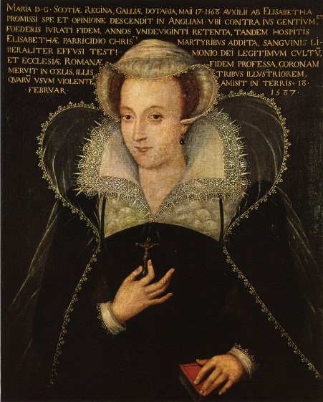**The role of Mary, Queen of Scots**

**THINK!**

Look back to the family tree on page 3. Who was Mary Queen of Scots and what was her claim to the throne?

Why may some people support her over Elizabeth?

From 1561 Mary ruled as Queen of Scotland! At first she seemed to rule well and listened to the advice of her ministers. BUT... The Scottish nobles were suspicious of Mary – they suspected she might have had something to do with her last husband’s death! They rebelled against her and made her give her throne up to her young son James in 1568.

**Mary was a bit of a problem for Elizabeth from the start!**

1. She was a Catholic and made it clear that she thought that she should be Queen of England.
2. Some English Catholics agreed with her! So Elizabeth kept her under lock and key in various posh prisons!
3. She was kept in in different castles in the North of England – in Sheffield, Bolton, Wakefield etc.
4. Mary was implicated in plots against Elizabeth as early as 1569 with the **Northern Rebellion** of Catholics.
5. In 1571 (after her ex-communication) The **Ridolfi Plot** planned to replace Elizabeth with Mary.
6. In 1583 there was another plot by Catholics to rebel with the help of Spain! **(Throckmorton Plot)**
7. The final straw was in 1586 when Mary smuggled secret codes out in beer barrels to a rich Catholic called **Anthony Babington.** They were planning to take Mary to London and overthrow Elizabeth! Caught in the Act! ...Mary’s servants took these letters straight to Francis Walsingham – Queen Elizabeth’s number one spy!

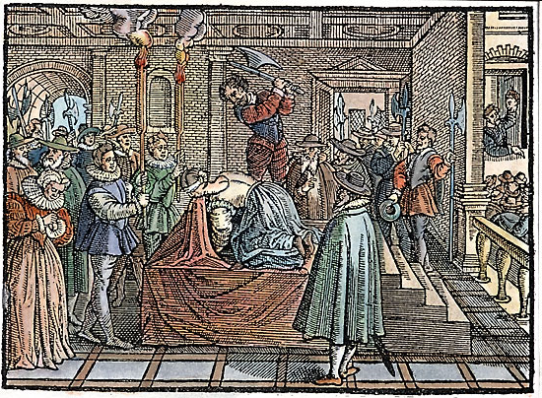**Mary’s execution**

In 1586 letters sent to Mary by a Catholic called Thomas Babington, were found. The letters revealed a plot to kill Elizabeth and replace her with Mary. Elizabeth had no choice but to sign Mary's death warrant. Mary Queen of Scots was beheaded at Fotheringay Castle on February 8th 1587.

**The Spanish Armada**

How much of a threat was the Spanish Armada?

This section will include:

* Reasons for the Armada
* War in the Netherlands
* Course of the Armada – events in the Channel
* Calais
* “Fireships” and return to Spain
* Results of the Armada
* Babington
* Role of Mary Queen of Scots

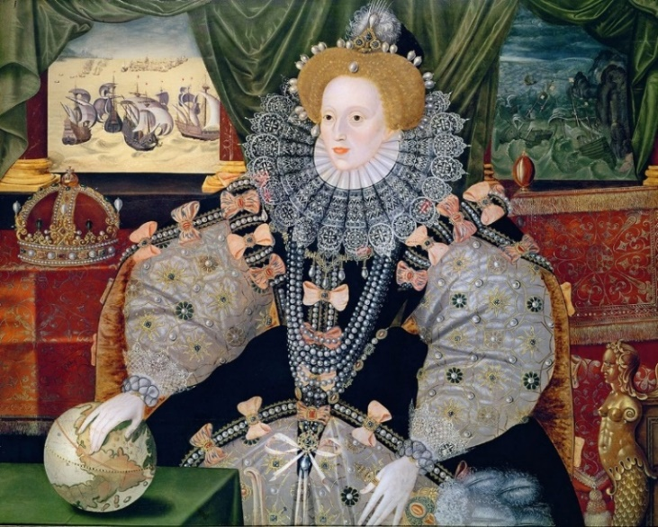

During the early years of Elizabeth’s reign Catholic Spain (the most powerful country in the world at that time) and Protestant England remained friendly. Over time tension built up leading to war in 1585 and an invasion of England in 1588, known as the Spanish Armada.

**What led to war?**

| **Issue** | **Explanation** |
| --- | --- |
| Religious differences | Spain was a Catholic country and England a Protestant country – meaning that the two rulers had conflicting spiritual outlooks. |
| Marriage rejection | King Philip of Spain had been married to Elizabeth’s sister, Mary I. When Mary died he offered to marry Elizabeth but she rejected him. |
| Piracy | English sailors like Hawkins and Drake attacked and stole treasure from Spanish ships in the New World. King Philip was furious but Elizabeth encouraged and rewarded adventurers. |
| The civil war in France | France was the traditional enemy of both England and Spain, meaning that they united together against the country. Now France was in civil war it was preoccupied with its own issues and no longer posed a threat – so the alliance between Spain and England was not necessary anymore. |
| Spain supported Catholic plots | There was evidence of Spanish support for plots to restore Catholicism to England, particularly involving getting Mary, Queen of Scots on the throne and Elizabeth off. |
| The Dutch Revolt | Protestants in the Netherlands began a revolt against Spanish rule in 1572. Elizabeth secretly supported the Dutch rebels because she knew the Dutch revolt would keep the Spanish too busy to threaten England. |
| Elizabeth’s army joined the Dutch rebels | Elizabeth sent an army to help the Dutch rebels fight Spain. For the first time English and Spanish armies were fighting each other. **England and Spain were now at war.** |

# Philip II of Spain

In Europe, Philip II was King of Spain. By 1588, he had conquered many other countries and ruled an empire:

* Spain was a Catholic country. In 1569, Philip expelled all Muslims from Spain, and he burned people who became Protestants.
* In 1571, the Spanish navy defeated the Ottoman Empire, leaving Spain in control of the western Mediterranean.
* In 1580, Philip conquered Portugal, which had a trading empire from Brazil to the East Indies.
* Spain had a **huge** empire in the New World, having conquered the Aztec and Inca empires. Fleets of ships brought back treasure to Spain which were frequently raided by English and French navies.
* Philip's nephew, Rudolph, was Emperor of Germany.
* Amazingly Philip had some minor claim to the English crown himself. Although he should have known better, he fantasised that English Catholics were waiting for him to arrive and liberate them.

# Why were the Netherlands so important?

* The Netherlands were ruled by Spain but the English saw the Netherlands as a vital place for trade.
* By 1572 Protestant ideas had spread in the Netherlands and Protestant Dutch rebels began a campaign for independence from Catholic Spain, leading to the Dutch Revolt.
* King Philip of Spain sent an army to defeat the rebels. Following the death of the Dutch rebel leader, William of Orange, Elizabeth was approached to become Queen of the Dutch. She declined but sent an army to fight with the Dutch against Spain.
* Throughout the 1590s the Dutch won several victories against the Spanish and by 1609, after Elizabeth’s death, the Dutch Protestants won control of Holland.

# Events leading up to Spain's attempted invasion of England

* England was a Protestant country, and executed Catholic priests. Philip wanted to make England a Catholic country again.
* The Dutch rebelled against Philip. At first, Elizabeth allowed Protestant Dutch pirates, known as the 'Sea Beggars', to use English ports, but she expelled them in 1572. In 1585, Elizabeth pledged support for the Dutch in their struggle for independence from Spain.
* English “privateers”, such as Francis Drake, who were really government-authorised pirates, robbed the Spanish treasure fleet.
* England wanted a base in the New World and between 1585 and 1587 the English set up a colony in Roanoke, Virginia.
* In 1587, Elizabeth executed the Catholic Mary Queen of Scots. Philip finally lost patience and made plans to invade England.

# England Vs. Spain

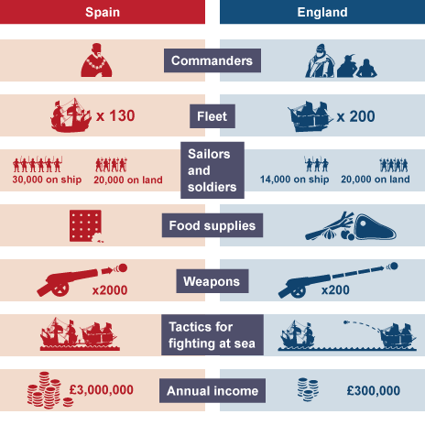Partly because of religious differences, and partly because of English interference in Spanish affairs in the New World and the Netherlands, King Philip of Spain decided to invade England and attempt to overthrow Elizabeth.

The greatest challenge to Elizabeth was first sighted in the English Channel on 29 July 1588. This was the Spanish Armada, a fleet of armed ships sailing towards England in a crescent formation.

Elizabeth was expected to protect her people from this invasion. How did the two sides line up?

|  | **Spain** | **England** |
| --- | --- | --- |
| Commanders | The Duke of Medina Sidonia - little experience of sailing. | Lord Howard of Effingham – little experience of fighting at sea, but Drake and Hawkins were both very experienced. |
| Fleet | 130 ships - 64 battleships, 22 huge galleons and 45 converted merchant ships. | 200 ships - 54 strong, light and fast battleships, and 140 converted merchant ships. |
| Sailors and soldiers | 30,000 men on board the fleet and 20,000 soldiers on land. | 14,000 men on board the fleet and 20,000 soldiers on land. |
| Food supplies | Not fresh – six months’ worth of supplies were stored on the ships. | Fresh food supplied daily. |
| Weapons | 2,000 large cannon – could fire heavy cannon balls, but only over a short distance and were slow to load. | 200 smaller cannon – could fire over long distance and were quick to load. |
| Tactics for fighting at sea | Get close so men could board and capture the enemy ships. | Destroy enemy ships by firing cannon at them from a distance. |
| Annual income | £3 million. | £300,000. Parliament did grant Elizabeth taxes to top this up. |

# Philip’s plan

1. Gather a huge Armada of 130 ships in Spain, under the Duke of Medina Sidonia.
2. Sail to the Netherlands to pick up the Spanish army, led by the Duke of Parma.
3. Invade England.

However:

* In 1587, a year earlier, Drake attacked Cadiz and destroyed over 100 of Philip's fleet in the arbour.
* Philip assembled another fleet in 1588, but it was hastily provisioned and badly equipped.
* Medina Sidonia begged not to be put in charge.

# What happened during the Spanish Armada?

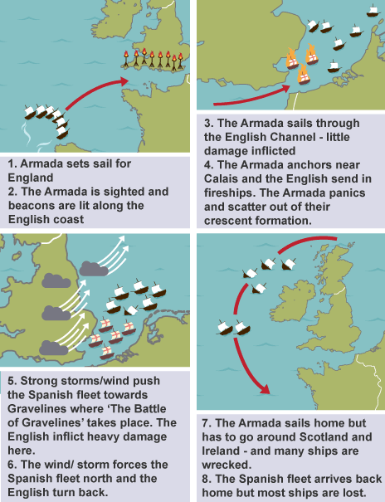

* The Armada leaves Lisbon on 28 May 1588. It’s delayed by storms and repairs, and finally sets sail for England on 21 July.
* The Armada is sighted by the English from Lizard Point in Cornwall. Warning beacons are lit along the English coastline.
* The Armada continues through the English Channel now chased by English ships, but suffers little damage.
* The Armada anchors near Calais where more troops are meant to join, led by the Duke of Parma, but the English send burning fire ships into the fleet. The Spanish ships panic and are scattered out of formation.
* The Spanish ships are blown towards dangerous sandbanks and the English attack again in the Battle of Gravelines. This time they battle at close range and significant damage is inflicted to the Spanish fleet.
* The Armada is forced north around the east coast of Britain and the English fleet turn back after food and ammunition supplies run low.
* The Armada sets sail for home but are forced around Scotland and Ireland. Many ships are wrecked in storms and thousands of sailors drown.
* The surviving Spanish ships arrive back in Spain, but almost half of their fleet is lost.
* Victory for England.

# Casualties of battle

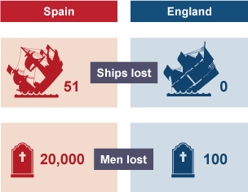Both sides suffered casualties as a result of the Armada but English losses were relatively minor compared to those of the Spanish. England lost just 100 men compared the 20,000 men and 51 ships lost by the Spanish.

However, despite England’s victory several thousand men died from illness and disease in the weeks following the battle.

*“It was bad luck, bad tactics and bad weather that defeated the Spanish Armada.” -* **Robert Hutchinson, Historian - BBC History Magazine**

Bad weather was certainly one factor that contributed to the Spanish defeat, but there were other factors too:

| **Factor** |  |
| --- | --- |
| Leaders | The Duke of Medina Sidonia led the Spanish fleet, but he was inexperienced in naval battle and so made some fatal errors in his planning and tactics. |
| Planning | The strength of the Spanish fleet came from its crescent formation plan – but when the English broke this up with their fireships, the Spanish became vulnerable and exposed to attack. |
| No reinforcements | The Spanish plan relied on stopping to pick up the Duke of Parma’s army to boost their numbers, but the fleet was unable to anchor and so never picked them up. |
| Tactics | Spanish tactics were to get close enough to English ships to board them, whereas the English tactic was to attack from a safe distance. |
| Ships | Spanish ships were slower and less equipped for the bad weather than the English ships. |
| Weapons | The English ships had cannon they could fire at a safe distance and could be reloaded quickly. The design of the Spanish cannon meant that they could only fire over short distances and were slow to re-load. |
| Support | The Spanish overestimated the level of support there would be in England for Spanish control and a return to Roman Catholicism. |
| Weather | The lack of a secure port where the Spanish could take shelter meant that the Spanish ships were buffeted by the wind. The thinking was that God intervened and the windy weather was a sign that God was on Elizabeth’s side. |

**Philip was temporarily halted.**

But:

* The defeat did not harm his control over his empire which continued to grow after his death in 1598. Spain would remain a dominant ‘super-power’ for a further 100 years.
* He tried other armadas in 1596 and 1597. Both were destroyed by storms.

**The English rejoiced** – they took it as a sign that God was on their side, even celebrating a national day of Thanksgiving for its victory over Spain on the 24th November.

But:

* The English did not defeat Spain and the war dragged on.
* An English naval attack on Portugal in 1589 failed.
* In 1595 a small Spanish force raided Cornwall.

**The Puritan threat**

Why did the Puritans become an increasing threat during Elizabeth’s reign?

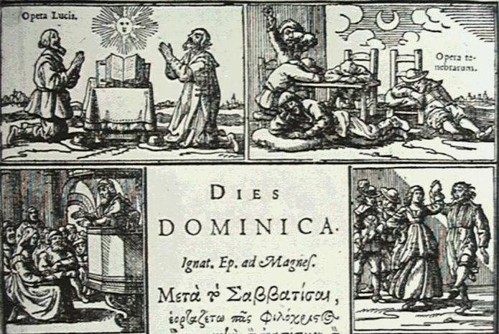

This section will include:

* Puritanism
* Challenge to the Settlement
* Puritan opposition in Parliament and Privy Council
* Measures taken to deal with the Puritan challenge
* Babington
* Role of Mary Queen of Scots

**The increasing threat from Puritanism**

**What was Puritanism?**

Puritans are very strict Protestants who believe in living a very simple life. They believed priests had too much power and thought that churches should not be run by Bishops appointed by the King/Queen but by ministers elected by church members. Puritans disapproved of:

* Playing sport
* Music in church services
* Bull and bear bating
* Pubs
* Christmas day celebrations
* Dancing
* Swearing

**Puritan attempts to change the Settlement from within the Church;**

There was no organised movement from within the Church but some Puritan individuals thought the Prayer Book and Church Services were too Catholic and wanted a more Calvinist form of Prayer Book. Puritans hated anything that reminded them on Catholicism

They resented that the Settlement had been forced on them without any consultation.

They did not think Elizabeth’s settlement was final and some took on positions in the Church hoping to change it from within. These included:

Edmund Grindal- the Bishop of London

John Jewel- The Bishop of Salisbury

Between 1559-1563 Puritan Clergy pushed for the removal of elements of Elizabeth’s Church which they thought were too Catholic. They asked that:

* Holy days e.g. Christmas were abolished (got rid of)
* Organ music to accompany hymns was abolished
* The sign of the cross was omitted from the baptism ceremony

They put these ideas forward in a petition to an assembly of clergy and they were only defeated by one vote showing many people within the church agreed with these ideas. Elizabeth then set out strict rules for how church services should be run and 37 clergy were removed from post because they failed to follow the rules. After this opposition focussed on the wearing of Anglican robes which Puritans thought were too Catholic in their appearance.

The Puritan campaign overall had little effect as Puritan bishops did not resign deciding it was better to work for reform from within the Church than desert it. As a result, after 1566 most Puritan opposition came from outside the Church.

**Puritan opposition in Parliament**

In the 1570s a small but influential group of Puritans began to push for basic changes to the Church through Parliament. The most famous of these was **Thomas Cartwright** who demanded:

1. The position of archbishop should be abolished
2. How each church was run should be down to the ministers in charge of it, not the government
3. Church minsters should be elected by the congregation (people who went to the church)

Think- why do you think Elizabeth was reluctant to introduce these changes?

Other challenges were also made in Parliament including:

|  |  |  |
| --- | --- | --- |
| **Date** | **Challenge** | **Government reaction** |
| April 1571 | Walter Strickland introduced a bill asking for changes to the Book of Common Prayer (to make it less Catholic). | Strickland was not allowed to attend the House of Commons again. |
| 1572 | A bill was introduced asking to remove certain ceremonies from the Prayer Book. | The Queen said there could be no further discussion on religious matters in Parliament unless her bishops gave permission for it. |
| 1572 | Puritans produced a number of publications (leaflets/books) criticising the way the church was run. | The authors were imprisoned and Elizabeth destroyed Puritan printing presses. |
| 1587 | Two Puritans (Anthony Cope and Peter Wentworth) argued MPs should have the right to discuss religious matters in Parliament. | Elizabeth ordered their imprisonment and her Privy Council stopped MPs from discussing this anymore. |

Think- Why do you think Elizabeth reacted in this way or each of the challenges? Was she fair or particularly unkind?

**The trial and execution of John Penry, 1593;**

* John Penry was a Puritan author
* He wrote a number of books criticising the Church and the way in which it was organised.
* He was arrested in 1587 for writing a book which was presented to Parliament and asked for more preaching in churches in Wales.
* In 1588 he became involved with Robert Waldegrave's secret printing press producing two further books of his own in 1588. These were fiercely criticised by the Church of England which saw any attack on the established church as treason. Penry was forced to keep on the move to avoid arrest and the press itself operated from several sites around London, and at Fawsley and Coventry.
* In 1592 he moved to London and set up a congregation which met in secret, often in open air, risking arrest and execution.
* He himself was betrayed by the vicar of Stepney and arrested in March 1593. Despite protesting his loyalty to his Queen and his country and a personal interview with Lord Burghley he was condemned to death and was executed on 29 May 1593 at St Thomas a Watering.

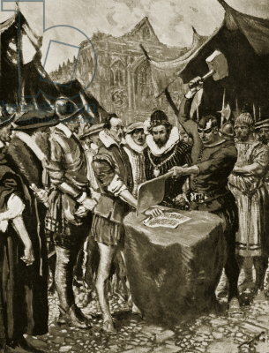**Situation at the end of Elizabeth's reign**

By the end of Elizabeth’s reign Puritanism had declined and the Puritan threat was reduced. This was because:

1. Elizabeth took a strong stand against them closing down their printing presses and imprisoning extremists. **John Stubbs** even had his hand cut off publically for writing a pamphlet criticising Elizabeth.
2. She had some key Puritans executed.
3. In 1583 she appointed **John Whitgift** as Archbishop of Canterbury. He was very anti-Puritan.
4. By the 1590s many of the leading Puritans who opposed her Church had died.
5. In 1593 Elizabeth passed an Act which made Puritanism an offence.