Germany 1919-1991
Revision Workbook

Name ____________________________

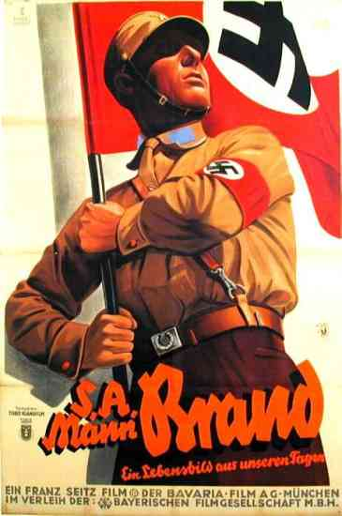

Topic | Tick when completed | Teacher signature- completed | Red | Amber | Green
Treaty of Versailles and the Constitution
Opposition to Weimar
Occupation of the Ruhr and Hyperinflation
Golden Years
Rise of the Nazis
Chancellor to Dictator
Control of the people
Life for women and children
Treatment of Jews
Opposition to the Nazis
Life during World War II
The division of Germany into East and West
The Berlin Blockade and the Berlin Wall
Willy Brandt and Ostpolitik
Helmut Kohl and the Reunification

The Weimar Republic
- Who was in charge of Germany before WW1?

- What was the name of the new Socialist leader?

- Why do you think he may be disliked from the start?

Name all the terms of the Treaty of Versailles and explain what it meant for Germany.
Term | Describe it: | How would this affect Germany?
B
R
A
T
S

The Weimar Constitution
Fill in the gaps:
The President
- Elected every ________
- Appoints the Chancellor
Article 48

The Chancellor
- Appointed by the President
- Had to have the support of the _________ of the Reichstag

The Houses of Parliament
The German people
- Over ___ can vote
- Freedom of _______

Reichstrat
- The Upper house
- German states sent a representative
Reichstag
- The lower house
- Proportional ___________

Strengths | Weaknesses
Opposition to Weimar:
 | The Spartacist Uprising | The Kapp Putsch | The Munich Beer Hall Putsch
Who?
When?
Why?
What happened?
How was it stopped?
How significant was it?

Occupation of the Ruhr and Hyperinflation:

France and Belgium….

Germany could not afford to pay back her reparations to France and Belgium.

In order to pay them the government….

This led to….

The Weimar Republic told Germans to…

The Golden Years:

Describe the following and judge how successful they were:

The Rentenmark:

The Dawes Plan:

The Locarno Pact:

The Kellogg-Briand Pact:

The Young Plan:

The Rise of the Nazis:

Nazi tactics

Hitler’s personal appeal The Great Depression
Why did people support the Nazis?

Weaknesses of the Weimar Republic Propaganda

Plan the following exam question:

How far was The Great Depression the main reason for Nazi support?
Agree | Disagree
Conclusion:

The Secret Deal:

In March 1932, Hitler challenges Hindenburg for the Presidency. He comes second. In the July 1932 election, the Nazis get ___________ seats. They are now largest party in the Reichstag. Hitler demanded the post of _______________ from Hindenburg but he would not give it to him. Hindenburg viewed Hitler as a thug. He keeps Chancellor Von Papen in place Von Papen loses the confidence of Hindenburg as he had ________________ from the Reichstag. _____________________ persuades Hindenburg to give him the job as Chancellor and Von Papen is annoyed at being pushed out, he becomes determined to regain power. However, ________________ also does not have the support of the Reichstag, as the Nazi party continuously ______________ whenever he attempted to pass laws. Von Papen, looking for revenge, meets with Hitler in secret in _________________. He suggests to Hitler that he could lead the government along with other Nationalist leaders with Von Papen as ____________________. Scheming and plotting took place. Leading businessmen were persuaded by Von Papen that Hitler would be the right man to lead Germany and save it from Communism. Von Papen convinces President Hindenburg to give Hitler the job as _______________. He said he could control Hitler like a __________________. Hindenburg is persuaded as he is fearful of a civil war if he does not give Hitler the job. They also believed they could control Hitler because there were only ________ Nazis in the Cabinet. On the _________________________________ Hitler is made Chancellor of Germany. He had achieved it by legal and democratic means.

Consolidation of Power: Chancellor to dictator

List 3 things that limited Hitler’s power after he became Chancellor:
1.
2.
3.

Describe the event and explain how it allowed Hitler to consolidate power:
Date | Event
27th Feb 1933
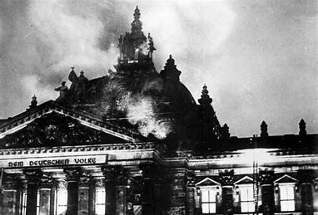
28th Feb 1933
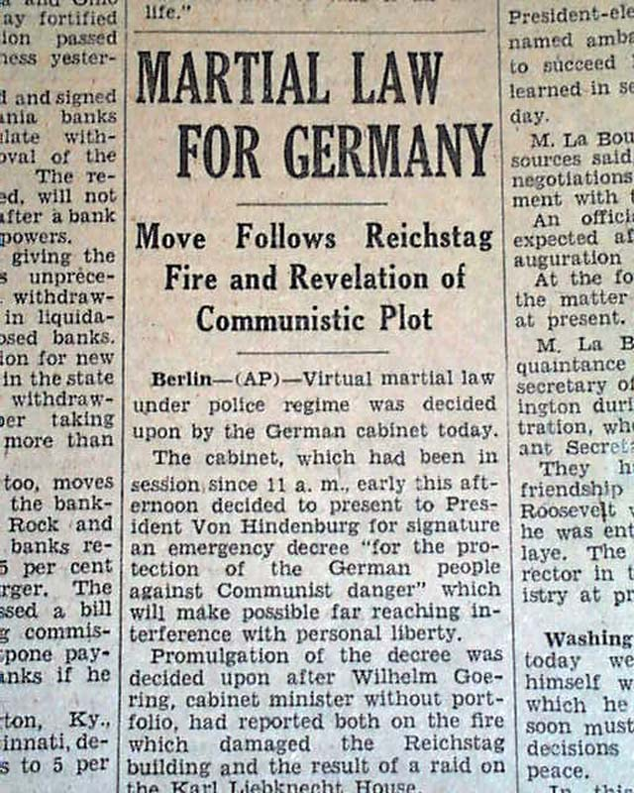

23rd March 1933

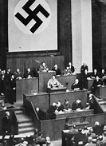
March-July 1933
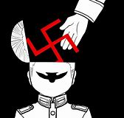

30th June 1934
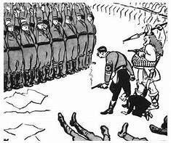

19th August 1934
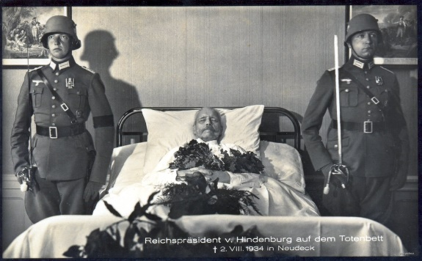

Plan the following exam question:
Explain why the Reichstag Fire of 1933 was important in Hitler’s consolidation of power between 1933 and 1934?

Context:

Describe:

Explain how important:

Nazi Control:

How did Hitler control the people by using the carrot and the stick? Write around the scales. Don’t forget to include the different economic organizations set up by Hitler.

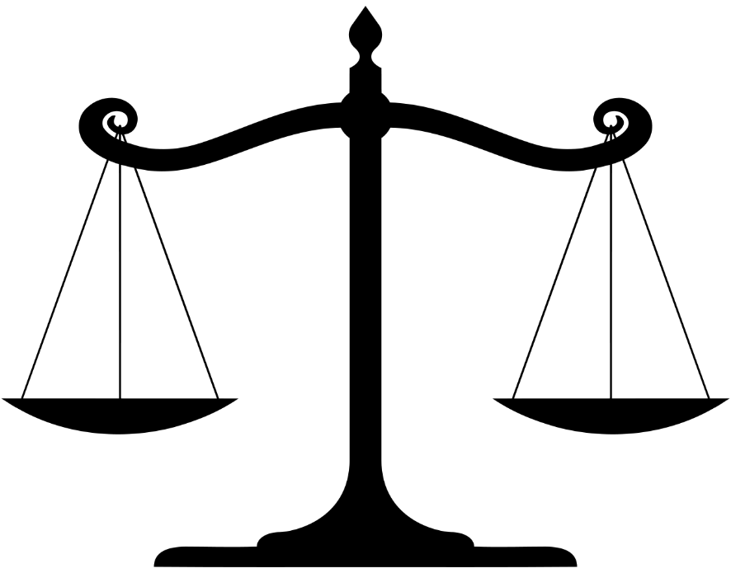

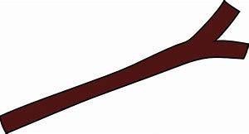

Were the scales balanced or unbalanced in Nazi Germany? Why?
____________________________________________________________________________________________________________________________________________________________________________________________________________________________________________________________________________________
Life for women:
Annotate the pre-1933 woman and the post-1933 woman. How did the Nazis change women’s lives?

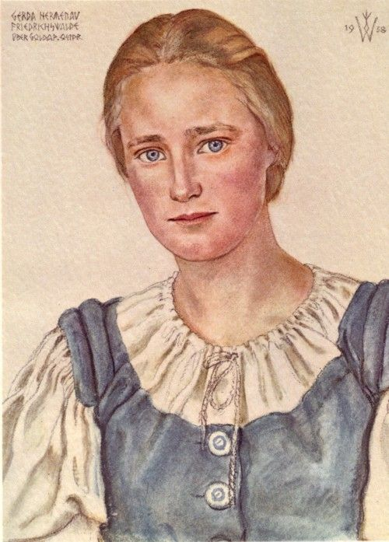

Did all women’s lives change?
______________________________________________________________________________________________________________________________________________________________________________________________________________________________________________________________________________________________________________________________________________________________________________________________________________________________
Children in Nazi Germany:
Draw on and label the image to show what a Nazi school would look like. Think about lessons, textbooks, teachers, students, decorations etc. Challenge – how would life differ for boys and girls? How would life differ for Jewish children?

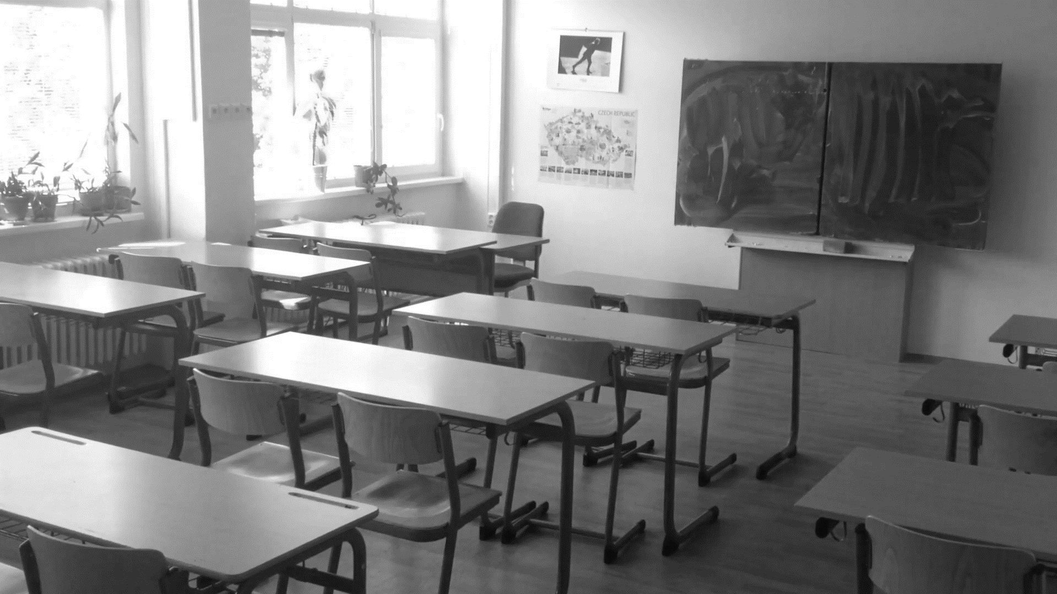

The Treatment of Jewish people in Nazi Germany:
- Fill in the graph on how the treatment of Jews changed over time.
- Annotate on the graph what the main turning points were and why.

Horrific

Bad
1933 1934 1935 1936 1937 1938 1939 1940 1941 1942 1943 1944 1945

Plan and answer one of the following questions (6m)
- How far did the lives of women change under the Nazis?
- How far did the lives of children change under the Nazis?
- How far did lives change during WW2?
- How far did the lives of Jews change either from 1933-1939 OR 1939-1945?

Before: | After:

________________________________________________________________________________________________________________________________________________________________________________________________________________________________________________________________________________________________________________________________________________________________________________________________________________________________________________________________________________________________________________________________________________________________________________________________________________________________________________________________________________________________________________________________________________________________________________________________________________________________________________________________________________________________________________________________________________________________________________________________________________________________________________________________________________________________________________________________________________________________________________________________________________________________________________________________________________________________________________________________________________________________________________________________________________________________________________________________________________________________________________________________________________________________________________________________________________________________________________________________________________________________________________________________________________________________________________________________________________________________________________________________________________________________________________________________________________________________________________________________________________________________________________________________

Opposition to the Nazis:

Describe what the following groups did to oppose the Nazis:

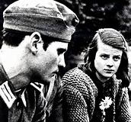

Hans and Sophie Scholl

Edelweiss Pirates
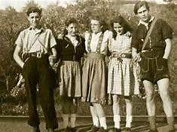

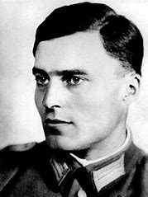

Claus Von Stauffenburg

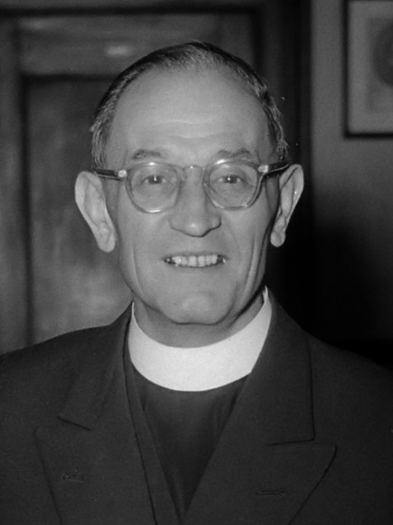

Martin Niemoeller
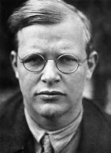
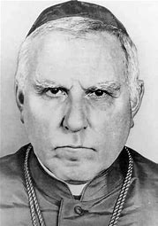

Pastor Bonhoeffer

August Von Galen
Life during World War Two:
How far did life change during the War?
 | 1939-1942 | 1942-1945
Rationing
Evacuation/
bombing
Women
Propaganda
War effort

What was the turning point and why? ____________________________________________________________________________________________________________________________________________________________________________________________________________________________________________________________________________________
The Division of Germany:

What was decided at the Yalta and Potsdam conferences and why?
Yalta | Potsdam

What were the Nuremburg Trials and why were they important?
_________________________________________________________________________________________________________________________________________________________________________________________________________________________________________________________________________________________________________________________________________________________

Draw and label a scene from East and West Germany in the boxes:
East:

West:

Berlin Blockade
Explain the Berlin Blockade using the following source:
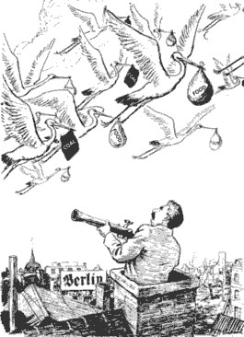

___________________________________________________________________________________________________________________________________________________________________________________________________________________________________________________________________________________________________________________________________________________________________________________________________________________________________________________________________________________________________________________________________________________________________________________________________________________________________________________________________________________________________________________________________________________________________________________________________________________________________________________________________________________________________________________________________________________________________________________________________________________________________________________________________________
Berlin Wall:
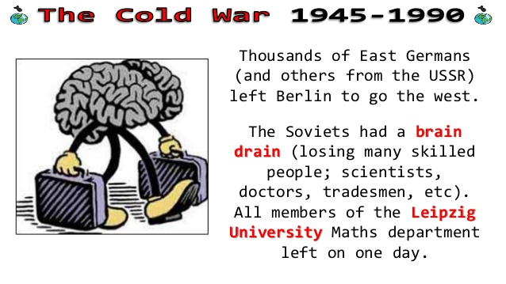

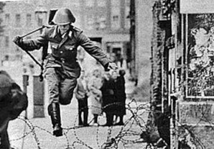

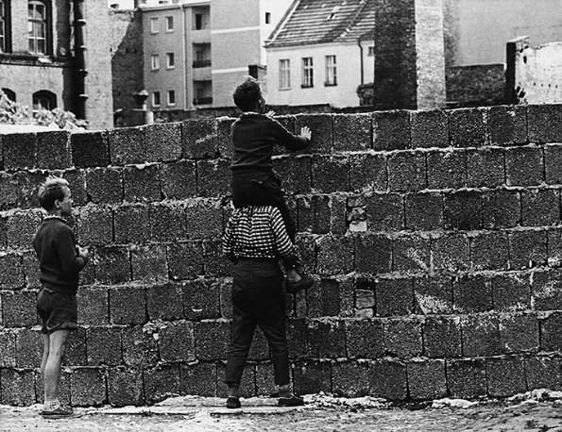

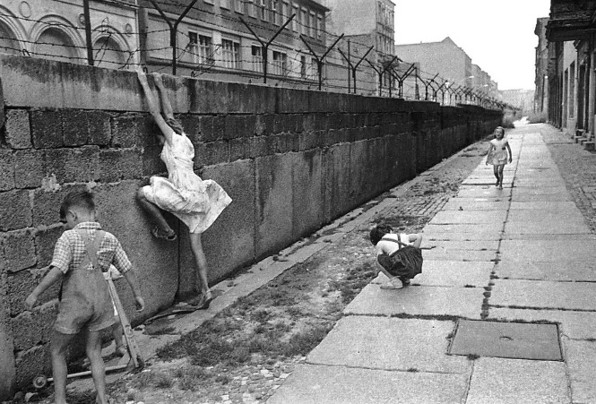

Explain how and why the Berlin Wall evolved?
________________________________________________________________________________________________________________________________________________________________________________________________________________________________________________________________________________________________________________________________________________________________________________________________________________________________________________________________________________________________________________________________________________________________________________________________________________________________________________________________________________________________________________________________________________________________________________________________________________________________________________________________________________________________________________________________________________________________________________________________________________________________________________________________________________________________________________________________________________________________________________________________________________________________________________________________________________________________________________________________________________________________________________________________________________________________________________________________________________________________________________________________________________________________________________________________________________________________________________________________________________________________________________________

Willy Brandt and Ostpolitik
Describe Ostpolitik in 5 key points.
1.

2.

3.

4.

5.

How significant was Ostpolitik?
___________________________________________________________________________________________________________________________________________________________________________________________________________________________________________________________________________________________________________________________________________________________________________________________________________________________________________________________________________________________________

The Reunification of Germany
How and why did Mikhail Gorbachev learn from this image of events at Tiananmen Square? What did he do differently?
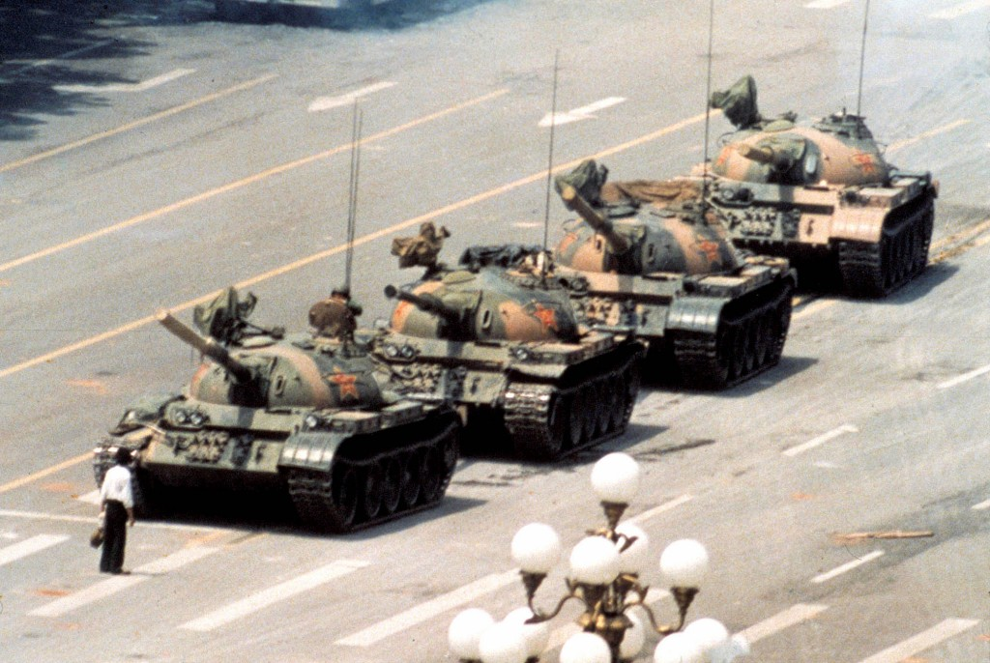

___________________________________________________________________________________________________________________________________________________________________________________________________________________________________________________________________________________________________________________________________________________________________________________________________________________________________________________________________________________________________________________________________________________________________________________________________________________________________________________________________________________________________________________________________________________________________________________________________________________________________________________________________________________________________________________________________________________________________________________________________________________________________________________________________________
Describe the role of Helmut Kohl in the reunification of Germany. What 5 key things did he do and how did they contribute to the reunification?
1.

2.

3.

4.

5.

How significant was Helmut Kohl in the reunification of Germany?
___________________________________________________________________________________________________________________________________________________________________________________________________________________________________________________________________________________________________________________________________________________________________________________________________________________________________________________________________________________________________

