Elizabethan England c.1568-1603
Revision Workbook

Name ____________________________

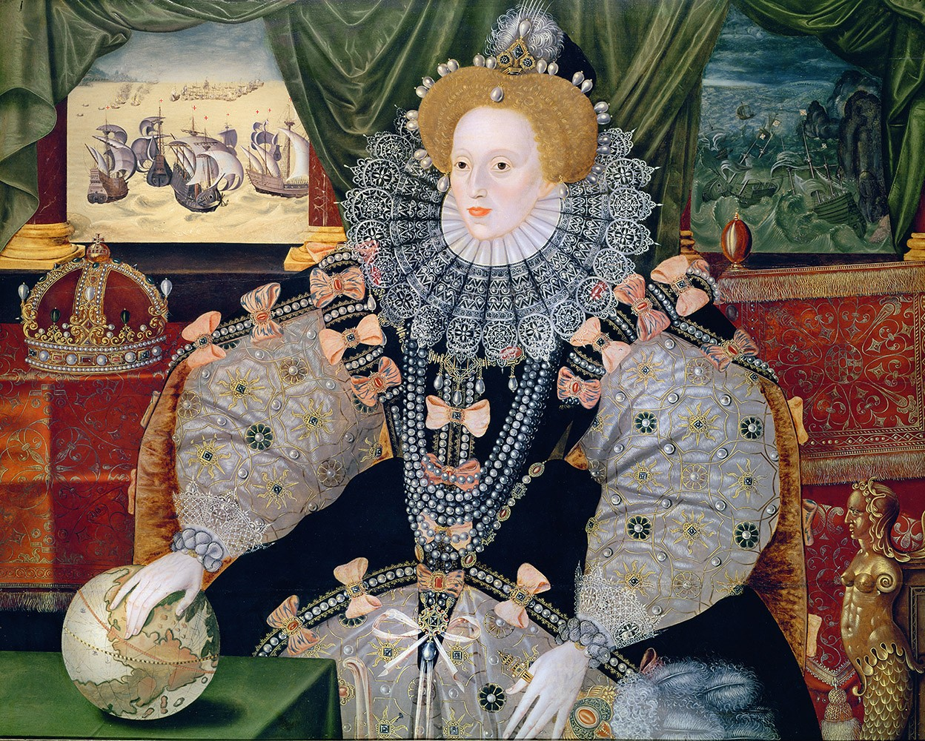

Topic | Tick when completed | Teacher signature- completed | Red | Amber | Green
Elizabeth’s portraits and coronation
The Elizabethan government
The Elizabethan court
Poverty- causes and solutions
Lifestyle of the Rich and Poor
Elizabethan Popular entertainment and Theatres
The religious settlement
Mary Queen of Scots
The Catholic threat
The Puritan threat
The Spanish Armada

Elizabeth’s background and character
Queen Elizabeth I of the House of Tudor

Date when reign started: Date of Death:

Religion: __________________________
Family:
__________________________________________________________________
______________________________________________________________________________________________________________________________________________________________________________________________________
______________________________________________________________________________________________________________________________________________________________________________________________________
__________________________________________________________________

Character:
__________________________________________________________________________________________________________________________________________________________________________________________________________________________________________
Upbringing and the impact this had on her life and reign: ________________________________________________________________________________________________________________________________________________________________________________________________________________________________________________________________________
Why did people not want Elizabeth to be queen? Give two of the most important reasons.
- ________________________________________________________________________________________________________________________________________________________________________________________________________________________
- ________________________________________________________________________________________________________________________________________________________________________________________________________________________

The Elizabethan Government
Answer the following questions:
- How many times did Elizabeth call Parliament through her 45 year reign?
- What was Parliament’s main function/role?
- What did Elizabeth ban Parliament from talking about?
- Why was Parliament important?
- What were the two main roles of the Privy Council?
- Elizabeth believed in Divine Right. How did this affect her relationship with Parliament?
- What was Patronage?
- What is a faction? Give an example of a faction.
- Name the unpaid local government positions.
- What were the main roles of the:
- Lord Lieutenant
- Justice of the Peace
- Sheriff
- Night watchman
- Overseer of the poor?
- Give one strength and one weakness of Elizabeth’s government.
 | Rich | Gentry | Poor
Homes
Fashion
Education
Leisure
Work

Poverty: Causes
Reason | Fill in the gap: | Why was this a problem? | Was it the government’s fault?
Increased population | A sharp rise in population from ____________________ in the 1540s to ___________________ by 1601. People also moved away from the ______________ to the ____________ in search of work.
Poor harvests | Bad harvests especially in _______, ________ and ______.
High prices | Wages could not keep up with rising prices, especially ________________.
Dissolution of monasteries | This caused a rise in ______________ and took away the vital role of ____________________.
Changes in the cloth industry | A decline in ___________ caused the cloth trade to collapse.
Change in farming methods | Farmers switched from ______________ to ______________ and ____________ common land and employed fewer labourers.
Rack Renting | Sharp increases in _________ that many _____________________ were unable to pay the higher rents and were _____________.
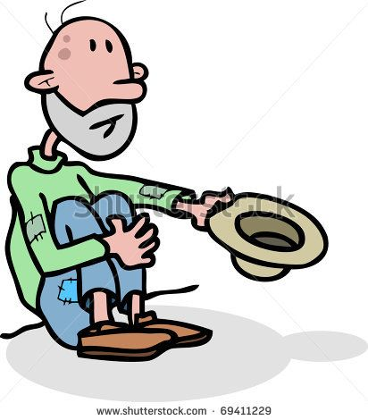
Describe the two categories people believed the poor could be split into:

Identify the type of vagrant:
1. I was once a farmer but after a series of bad harvests in 1596 and 1597 meant I was unable to continue farming the land. I lost my job which, along with a steep rise in food prices, means I am now starving. | 2. I was once a soldier fighting for the English during the Spanish Armada. However, the war has ended and I am no longer needed. I now wander through the countryside trying to find work. In order to survive I rob, use threats or beg.
3. In the last few years the population of my town has risen significantly and people are moving away from rural areas. This has meant there are not enough jobs for everyone and you were made unemployed. I have no job so you now wander through towns. In order to attract sympathy, I tie arsenic on your skin to make it bleed. | 4. My name is Nicholas Blunt. I was once a tenant farmer. In the last few years my rent has risen sharply and I was unable to pay the high rent meaning I was evicted. In order to gain sympathy and good will from people I suck soap to fake foaming at the mouth.
5. I used to spin cloth for a living but due to poor relations with France and Spain following failed marriage matches and the Spanish Armada, exports have declined and I have lost my job. This also meant that I lost my house and my now wander from town to town trying to get food and money. One of my cunning techniques is to steel chickens by feeding them bread tied to a hook, carrying the birds away in the large sack on her back. | 6. I have a physical disability meaning working is almost impossible. I used to seek help from the monasteries but over the years, Protestant kings and queens have closed them down meaning I have nowhere to go for food and shelter. I have now found yourself homeless and hungry. I pretend to be mad, hoping that my threatening behaviour would result in charity donations through pity.
7. I used to work for a tenant farmer but with the changes to farming techniques I was no longer required and so turned to a life of crime. I now carry a long wooden stick and knock on the doors of houses seeking charity during the day to see what may be stolen. I use the wooden stick to reach through windows to steal clothes and valuables, which I later try to sell. | Answers:

Poverty: solution
Describe 4 Acts that Elizabeth’s government put in place to stop poverty.

Elizabethan Theatres
Identify these types of popular entertainment.
Who would have participated in them? I.e. rich or poor?
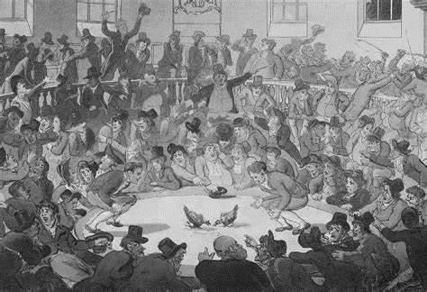
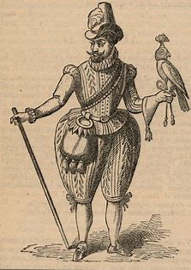
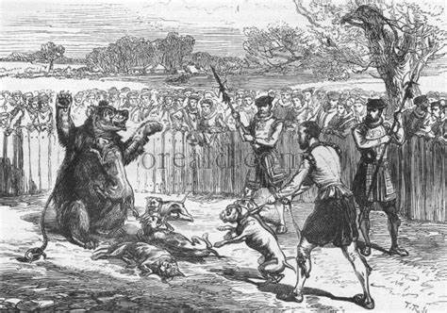

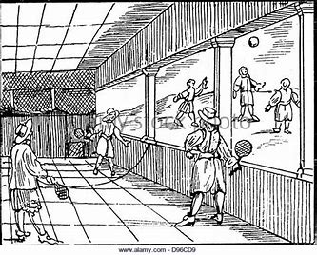
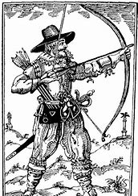
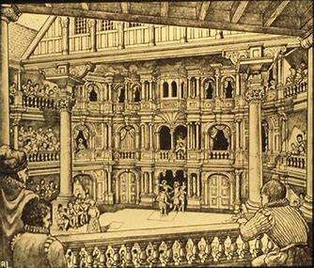

THE RELIGIOUS SETTLEMENT

After the extremes of the two previous reigns – Mary (Catholic) and Edward VI (Protestant)
Elizabeth deliberately tried to follow a middle way between the two beliefs. The Catholics
wanted nothing short of the total restoration of Roman Catholicism in England, whereas
Protestants wanted revenge for the persecutions that had taken place during Mary’s reign.
THE RELIGIOUS SETTLEMENT – THE MIDDLE WAY
Action taken to please Protestants (reforms) | Action taken to please Catholics (concessions)

These changes were brought about by two Acts of Parliament in 1559.
1. Act of Supremacy

2. Act of Uniformity –

Mary Queen of Scots
Religion: ____________
Family and background details:
__________________________________________________________________
______________________________________________________________________________________________________________________________________________________________________________________________________
______________________________________________________________________________________________________________________________________________________________________________________________________
__________________________________________________________________

Escape to England (1568):
__________________________________________________________________________________________________________________________________________________________________________________________________________________________________________
________________________________________________________________________________________________________________________________________________________________________________________________________________________________________________________________________________________________________________________
________________________________________________________________________________________________________________________________________________________________________________________________________________________________________________________________________
Why did Mary pose a threat to Elizabeth once she was in England?
- ________________________________________________________________________________________________________________________________________________________________________________________________________________________
- ________________________________________________________________________________________________________________________________________________________________________________________________________________________
- ________________________________________________________________________________________________________________________________________________________________________________________________________________________
BABINGTON PLOT AND EXECUTION ____________________________________________________________________________________________________________________________________________________________________________________________________________________________________________________________________________________________________________

Catholic threat | Puritan threat
- Northern Rebellion  - Excommunication  - Ridolfi Plot  - Throckmorton Plot  - Babington Plot | - Vestments Controversy  - John Stubbs  - Marprelate Tracts  - Proposals from Thomas Cartwright  - Threats from wthin Parliament
Write down evidence of how the Catholics and Protestants posed a threat to Elizabeth. Highlight which threat was the most significant from each side.
Overall, which religious side posed the biggest threat to Elizabeth and why?

Plan the following exam question:
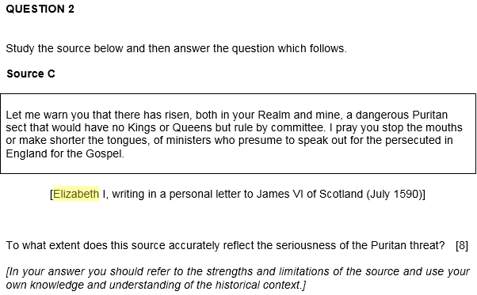
Give 4 pieces of evidence that agree with the interpretation: | Why does this person have this interpretation based on the origins?
Give 4 pieces of evidence that disagree with the interpretation. | Conclusion – to what extent do you agree?

War with Spain and the Spanish Armada
Causes of the Spanish Armada | Reasons why the Spanish Armada failed- refer to key events during the Spanish Armada
 | Spanish failures/ problems | English successes | Bad luck for the Spanish

Glossary of Key terms
Elizabethan England
Abdicate A king or queen giving up their throne.
Act of Supremacy Part of the Religious Settlement (1559). It made Elizabeth supreme governor of the Church of England. All clergy and officials had to swear an oath of allegiance to Elizabeth.
Act of Uniformity Part of the Religious Settlement (1559). It established the appearance of churches and the type of religious services they held.
Agent Provocateurs French term referring to agents who became a part of groups suspected of wrongdoing, and encouraged other members so that potential threats can be identified and arrested.
Altars The table in a church where mass is performed.
Arable farming Growing crops on farmland
Archbishop of Canterbury The most important clergyman in England.
Armada Spanish battle fleet of ships.
Astrolabe An instrument used by sailors to help with navigation at sea. It was circular.
Auld Alliance A friendship between France and Scotland.
Babington Plot (1586) A plan to murder Elizabeth and encourage English Catholics to rebel. It was similar to the Throckmorton Plot, and both Philip II and the pope supported it.
Baiting Irritating animals (often bears) and getting them to lash out. It was considered a sport.
Book of Common Prayer A prayer book created for the Religious Settlement
Cipher A secret way of writing in code
Circumnavigate To travel all the way around the world
Clergy Religious leaders, such as bishops and priests.
Colonies Lands under the control or influence of another country, occupied by settlers of that county.
Conspiracy A secret plan that aims to do something that breaks the law.
Coronation When a person is made monarch.
Court A group of people who lived in the same house or palace as the monarch. It was made up of the nobility.
Courtiers People who spent much of their time with the monarch. They were usually members of the nobility.
Crown The Crown means the monarch and their government.
Crucifix An image of Jesus Christ dying on a cross.
Death warrant An official order for the execution of a condemned person.
Diocese An area looked after by a bishop.
Dutch Revolt (1567-68) A Dutch, protestant rebellion against Spain and the Spanish Inquisition.
Ecclesiastical An adjective to describe things to do with the Church.
Economic recession When a fall in demand leads to falling prices and businesses losing money. This can lead to businesses failing and unemployment going up.
Edward VI King of England 1547-53. He was Elizabeth's brother and a Protestant.
Enclosure Replacing large, open fields with individual fields owned by one person.
Excommunicated A very severe punishment, imposed by the pope, expelling people from the Catholic church.
Expeditionary force An armed force sent to a foreign country to achieve a specific function or objective.
Fireships Empty ships set on fire and sent in the direction of the enemy to cause damage and confusion.
Galleons New ships built from the 1570s that were faster and easier to manoeuvre.
Gentry The social group below the nobility.
Hanged, drawn and quartered. A type of punishment for high treason. The offender was hanged until almost dead, cut open, had their intestines removed and finally chopped into four pieces.
Heretics People who have controversial opinions and beliefs that are different from the rest of society. This is what people were called if they denied the teachings of the Catholic Church.
Intermediary Someone who acts as a go-between when you can't directly communicate.
Jesuits Catholic priests, trained in Douai, whose purpose was to reconvert England to catholicism
Lords Lieutenant Men in charge of the local militia.
Justices of the Peace (JPs) Landowners who kept law and order in their local areas.
Mary I Queen of England between 1553-58. She was a Catholic and has burned almost 300 people for their religious beliefs.
Mary, Queen of Scots Queen of Scotland between 1542-67. She was a Catholic and Elizabeth's cousin.
Mass Roman Catholic service where Catholics are given bread and wine. Catholics believe that this involves the bread and wine turning into the body and blood of Jesus Christ.
Monarch The king or queen.
Monopoly When one person, or company, controls the supply of something. This means they can charge whatever price they like for it.
New World North and South America. Europeans only knew it existed after 1492.
Nobility The group at the top of society. Only the monarch is higher.
Papacy The system of Church government ruled by the pope.
Papal Bull A written order issued by the Pope.
Parliament An elected group of men who passed laws and controlled taxes. It was controlled by Elizabeth.
Patron Someone who gives encouragement or financial support to a person or a cause. E.g. Elizabeth was patron to many explorers in her reign as she funded their voyages and travels.
Penal Laws, 1581 Laws against Catholics, fining recusants £20 and calling conversion to Catholicism 'treason'.
Philip II of Spain King of Spain between 1556-98. He was Mary I's husband and a Catholic.
Priest hole Secret hiding places for priests after 1574.
Privateer Individuals with their own ships that capture other ships for their cargoes, often with authorisation or support from their government.
Privy Council A group of men who advised the monarch. They oversaw law and order.
Privy Councillor A member of the Privy Council.
Progresses Annual summer visits by Elizabeth and her court to different parts of England and Wales
Propaganda Biased information to promote a point of view.
Protestantism A branch of Christianity that believes the Bible should be translated into their own languages so people can engage directly with their religion.
Puritans Radical Protestants who believed in purifying Christianity by only including things mentioned in the Bible.
Quadrant Similar to an astrolabe, it was used by sailors to help with navigation at sea. It was the shape of a quarter circle.
Recusants Catholics who didn't attend church services from the Religious Settlement.
Religious Settlement (1559) An act to ensure that all of England was loyal to Elizabeth and her church.
Ridolfi Plot (1571) A plot organised by Roberto Ridolfi, an Italian banker, to murder Elizabeth, launch a Spanish invasion and put MQOS on the throne.
Robert Dudley, Earl of Leicester A Puritan noble and one of Elizabeth's favourites at Court.
Roman Catholic The form of Christianity which follows the Pope. It was followed by the whole of Western Europe until the 16th Century.
Rome Capital of Italy - but also used to mean the pope or Catholic Church.
Royal prerogative Something only the monarch could decide on.
Rural depopulation When the population of the countryside falls as people move away in search of a better life.
Sacraments Special Church ceremonies.
Sea Beggars Dutch rebels who fled the Dutch Revolt and attacked Spanish ships in the English Channel. Elizabeth allowed them refuge from 1567.
Secretary of State The most important member of the Privy Council.
Singeing of the King of Spain's Beard, 1586 An attack by Francis Drake on Philip II's port of Cadiz.
Sir Francis Drake An English merchant who made his name and fortune trading in the New World.
Sir Francis Walsingham Elizabeth's Secretary of State 1573-1590. He was chief spy-master and was responsible for evidence against MQOS for her execution.
Sir William Cecil Elizabeth I's Secretary of State until 1573, when he became Lord Burghley.
Spanish Inquisition A political and religious group set up by Spain in 1478 to keep Spanish territories Catholic. Anyone caught by the Spanish Inquisition who wasn't Catholic could be tortured or burned alive.
Spanish Netherlands In the Elizabethan period, the Netherlands belonged to Spain.
Subsistence farming Growing just enough to feed the family but not to sell.
Succession The plan of who was going to take the throne after the existing monarch died.
Tenant farmers Men who farmed on rented land.
Thomas Howard, Duke of Norfolk The most powerful noble in England.
Throckmorton Plot (1583) A plan for the French Duke of Guise (MQOS' cousin) to invade England, overthrow Elizabeth and restore Catholicism in England.
Tower of London A prison in London that was often used to hold important prisoners.
Trade embargo When a government bans trade with another country
Unskilled labourers People at the bottom of Elizabethan town society.
Vagabonds Homeless people without jobs, who roamed the countryside looking or begging for money.
Vagrants Homeless people at the bottom of society.
Vestments Religious clothing worn by the clergy.
Visitations Inspections of churches and the clergy to ensure that everyone was following the rules. They began in 1559.
Walter Raleigh An explorer and courtier in Elizabeth's reign.

