USA 1910 to 1929
Revision Workbook

Name ____________________________

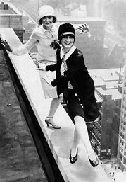

Topic | Tick when completed | Teacher signature- completed | Red | Amber | Green
Immigration
Red scare and the Palmer Raids.
Sacco and Vanzetti
Religious fundamentalism and the Monkey trial
Treatment of Native Americans
KKK and treatment of black Americans.
NAACP and the UNIA
Prohibition
Organised crime and Capone inc. Valentines day massacre
Harding and the Ohio gang – Tea pot Dome
Causes of the Boom
Bust
The Wall St Crash
The Cinema and stars
Jazz, the radio and the grammar phone
Women
Exam Technique

Immigration
By 1919 over ___ million people had immigrated to the USA. America was a mixing pot of different races, religions and cultures.
People came for a number of reasons.
Push factors such as . . . | Pull factors such as . . .

America let them in because it had a Open ________ Policy. The majority of immigrants, some _____ million entered the USA via ____________ Island in New York city. Not everyone was in favour however. Older immigrants in particular called for the government to close the door. These are still referred to as WASPs because they can be defined as. . .
W________________
WASPs had all the political, economic and social power in the USA.
A_________________
S_________________
P_________________
From 1917, the OPEN door began to close as the Republicans passed a string of laws which reduced the number of people allowed into the USA. This was mainly a result of the 1917 Russian revolution.
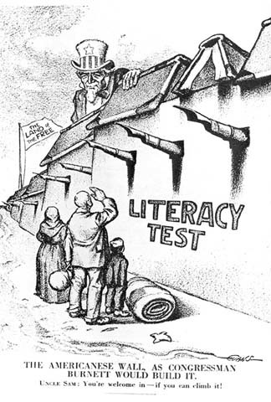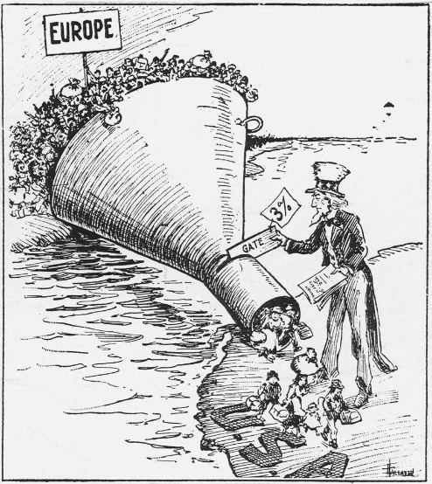
Annotate the images and link context from your own knowledge to the 2 different acts.
Complete the table detailing the 4 acts restricting immigration too the USA.
YEAR | Measure | Features
1917 | Literacy Act
1921 | Emergency Quota Act
1924 | National ___________ Act
1929 | Immigration Act
Key terms
Xenophobia - _________________________________________________________
Anarchist - __________________________________________________________
Trade Union- _________________________________________________________
Communist - __________________________________________________________
Sacco and Vanzetti.
Sacco and Vanzetti were Italian immigrants who were also ________________ (chose from above)
On 5th May 1920 they were arrested for ____________________________________.
The case against them was not strong however . . . as. . .

Despite this they were sentenced to death and died on ____________________ in the electric chair. More important than evidence in this case was . . .

The case is therefore significant as. . .

Religious Fundamentalism.
A Darwinist is someone who . . .
A religious fundamentalist is someone who . . .
They (RF) typically lived . .
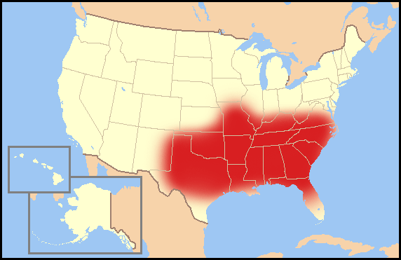

An example of a religious fundamentalist is Sister
Amy ________________ who gained fame by. . . .
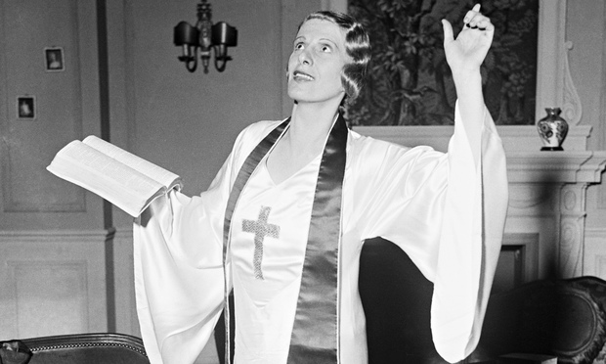
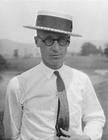 School teacher Johnny S_________
Religious Fundamentalists clashed with Darwinists in 1925 when
a science teacher in Tennessee taught ____________ ideas. This was bad as . . .

The case that followed is called the MONKEY TRIAL as . . .
In the box, detail and describe the key features and significance of the trial.
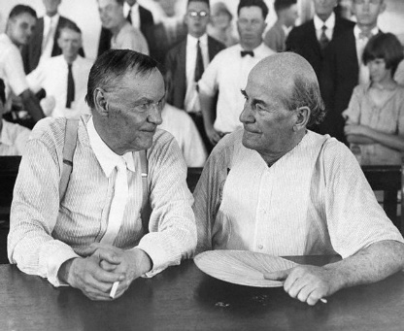
Defence attorney Darrow (D for DARWIN - left) and Prosecution Attorney Bryant (B for Bible - right)

Task.
Use the key details on the page above to complete a thought bubble about different people’s opinions about the trial. Consider how they might think and feel about the trial and the outcome.
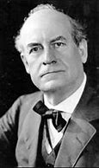

Prosecution – Bryant
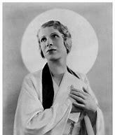

Sister Amy McPherson
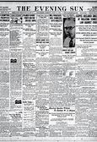

The Evening Sun newspaper

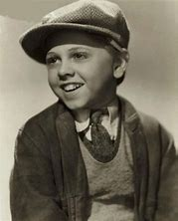
Billy Hoffer, a pupil in New York

Native Americans
100million native Americans were murdered by the US government.

Describe how Native Americans were treated in the USA
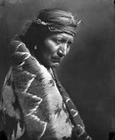

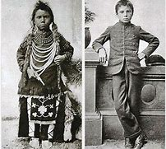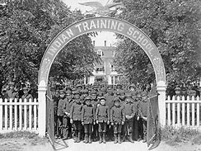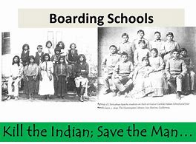
Task. – write a paragraph from the perspective of the child in the photo. Describe what the government has done to you and your family from his perspective. Why do you think these terrible things were happening?

Life for Black Americans in the USA

What problems did Black Americans face 1910-1929? 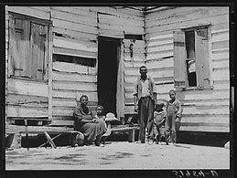

Key word checker.
The Jim Crow laws are ____________________________________________________________
Segregation is _____________________________________ for example . . .
Lynching is . . .
The KKK
Why did the KKK grow in popularity in the 1920s?
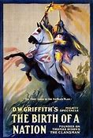
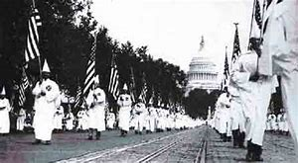

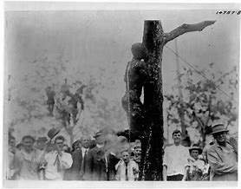
What kind of activities did the Klan engage in?
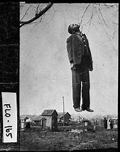

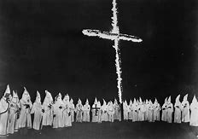

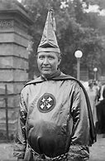
Why did the Klan decline in the late 1920s?

How did Black people deal with racial injustice?
Complete the table including details about some of the groups and individuals that worked to improve the lives and rights of Black people.
Organization or individual | What did they do? | Why are they significant?
NAACP

UNIA

W.E.B Dubois

Marcus Garvey

Paul Robeson

Countee Cullen
Between 1916 and 1920 1 million Black Americans migrated north in the hope of a better job and life, this was called the G___________ M_____________. They moved to places like Chicago, Detroit and New York and settled in Slums like H_____________ in New York where many found life just as difficult as it had been in the south.
In 1919 20 US cities experienced riots as Black people became more and more frustrated. However, some good did come out of the move north. Black culture moved with them, and many black musicians found work playing instruments in clubs and speakeasies. This led to the birth and development of Jazz and dances like the C_______________. This cultural shift is often referred to as the Harlem Renaissance.
Literacy Task. - Write a goodbye letter as a Black person to your little brother. He is too little to understand life for you in the south at this time. Explain what life is like and why you have decided to leave to find a better life in the north.

Prohibition 1919-1933
Reasons for Prohibition
Factor | Explain how this was a reason to support prohibition
Religion
Domestic abuse
Germans
Productivity
Poverty

Organisations such as __________________ and the Anti- Saloon _________ fought to make prohibition one of the top political issues in the early 1920s. The Prohibition Amendment (__ th), which stopped the _________, sale or __________ of intoxicating liquors was ratified in congress in January _____ and was scheduled to come into effect one year later. In _____ congress passed the ________ Act whereby The ___________________ (IRA) became responsible for enforcing Prohibition.

Complete the following key terms:
Speakeasy
Bootlegger
Bathtub gin
Moonshine
Rum Runner
Smuggling

What were the success and failures of Prohibition?
Success | Failure

Some examples:
- Lasted for 13 years
- 50,000 people died from poisoned alcohol by 1926
- Deaths from alcoholism had fallen by 80% by 1921
- Accidents at work decreased
- Not all states adopted the laws
- Increase in crime and corruption
Liver disease fell from 29% in 1911 to 10.7% per 100,000 people in 1929

Organised Crime
Explain why there was a rise in criminal gangs
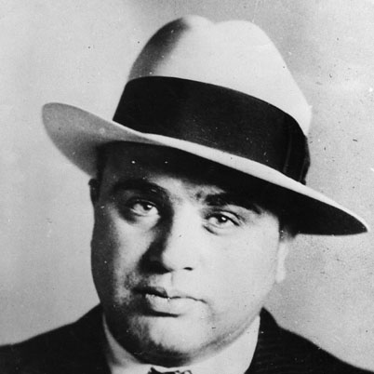
during the prohibition era.

Use the source and your own knowledge
to explain why gangsters became celebrities in the 1920s.

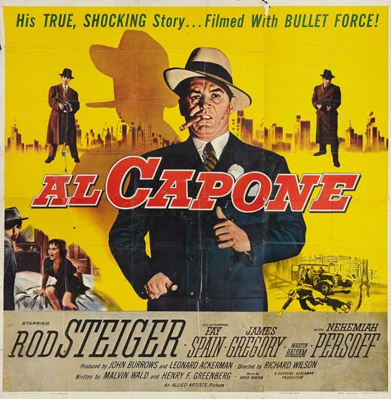
A poster advertising the film ‘Al Capone’, released in 1959.

Fill in the following report on the St Valentine’s Day Massacre

Date:

Who was there?

What happened? What did the police find?

Were there any witnesses?

Who was responsible?

What was the outcome/ significance of the massacre?

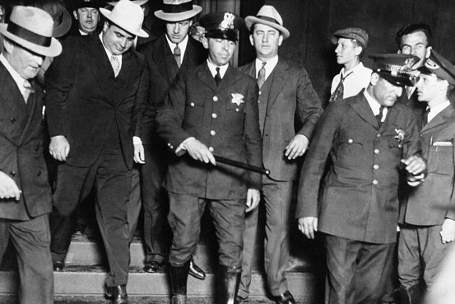
When and why was Al Capone finally arrested?

Government corruption

President Warren Harding surrounded himself with in a cabinet with friends and colleagues, many of whom were from ______ therefore known as ______________. However some of Harding’s friends used their positions to__________________________.

Task: Use the following pictures to explain what happened with regards to President Harding and the Teapot Dome Scandal of 1922.

________ Fall, Harding’s secretary of the interior leased government oil fields to wealthy friends in exchange for hundreds of thousands of dollars in bribes. The oil fields were supposed to be used for _______________ when the country was in a ________________. Fall received $____________ in cash and gifts but his erratic spending soon made other suspicious. When all evidence was released it showed that Fall had earnt $__________ from $_________ worth of oil. Mass investigations soon took place and in _____ Albert Fall was fined _______ and sentenced to __________.

Task: What is the purpose of the source below? – Annotate your answers.

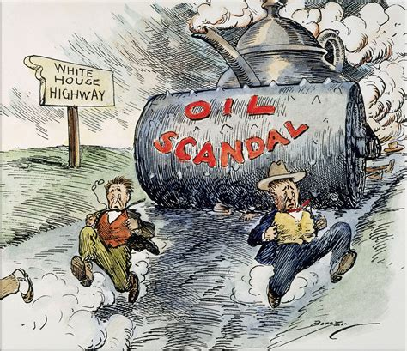

A cartoon that appeared in an American newspaper in 1922 showing the Teapot Dome Scandal. One of the figures running away is Albert Fall.

Task: Using the information from above, complete the following speech bubbles to explain how each person would have a different interpretation of the Prohibition Era.
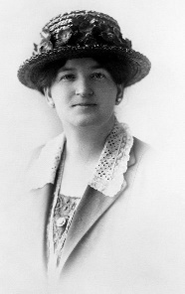

A woman from the anti-saloon league
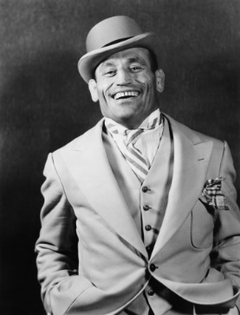

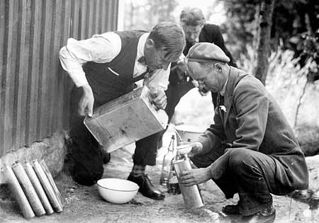
The owner of a speakeasy

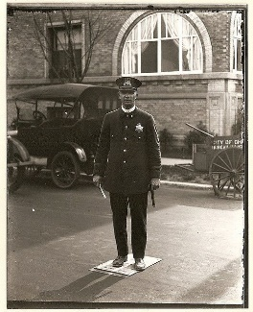

A bootlegger

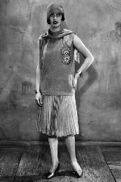
A policeman

A flapper

Gangsters
“Politicians are the biggest crooks in America.” Capone
What is Capone talking about? Why might Elliot Ness disagree?
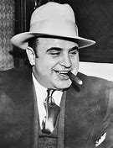
Arguments in favor | Arguments against
 | 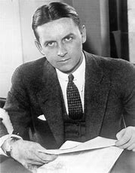
Key words to remember to include – Teapot Dome, Valentine’s Day Massacre, Prostitution, Bootlegger, Speakeasy, Harding, Ohio Gang, Moran, prohibition, corruption, Wyoming, $400,000, Edward Doheny, Harry Sinclair, Albert Fall.
Extension – What do you think? Was Capone or Fall worse?

Causes of the boom
Below are causes of the BOOM. Illustrate each factor and write a sentence linking how it led to prosperity.
Consumerism link – This led to the boom as it convinced people that the would be happy if they buy more goods. So they bought more which created more jobs.

Natural Resources

Immigration

World War 1

Republican policies

The stock market and speculation

Electrification

New technology

Advertisement

The Car Industry

Mass production

Easy availability of credit.
Literacy activity – Write a diary entry, a letter home pretending to be an immigrant, or a newspaper report of the Times. Describe what America is like and why you are excited to live in or visit a prosperous land like this! Don’t forget to describe and discuss some of the factors that have caused the boom!

Not everyone experienced prosperity however. Below are some of the groups. What might they say about America’s Golden era?
Black Americans
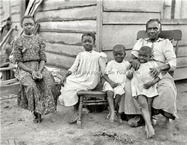

Farmers
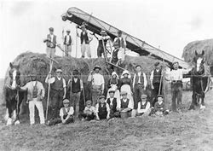

A coal worker
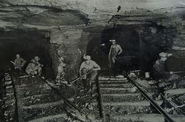

Immigrants
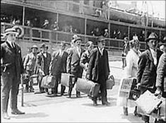
A textile worker
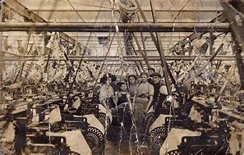

A railway worker.
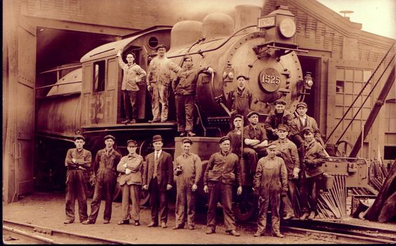
A unionist
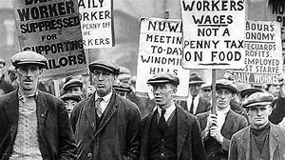

Challenge Q – Overall – do you believe the 1920s deserve to be called the ‘Golden era’ of American history? What is your opinion?

Bust
List the reasons why the boom came to an end in the table below than link why each factor/cause was significant in causing the economy to decline. TOP TIP – Remember to link like this in the exam!
Cause/ factor | Link – How did it lead to the bust?

Overall which factor was most significant in cause the bust?

Can you explain why people (like the man in the cartoon below), who saved their cash, never speculated on the stock market and never over spent in the shops could end up bankrupted and homeless by the Wall St Crash?
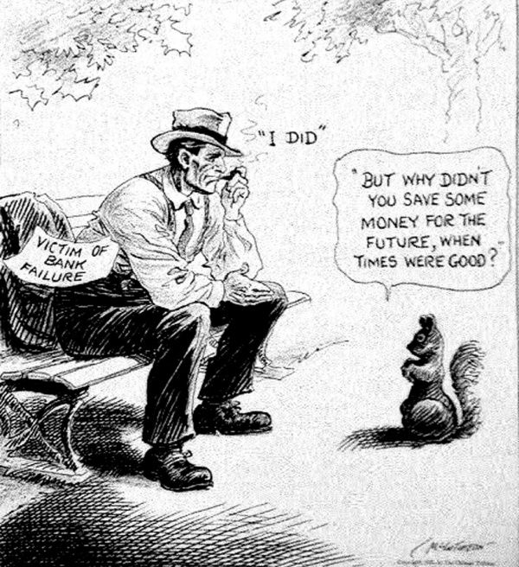

Wall Street Crash
Task – Draw your own satirical comic about the wall street crash. It could inform people about the possible causes, dates and key events. Use your imagination.

Guess who?
Label the pictures and include some fun facts about these amazing stars
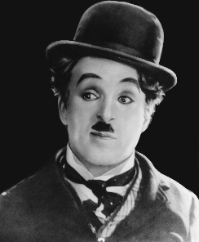CC
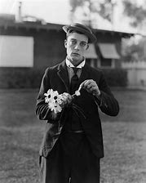BK
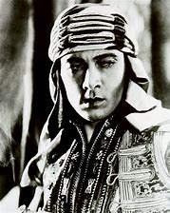RV
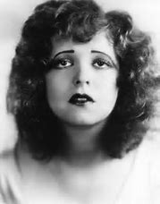CB
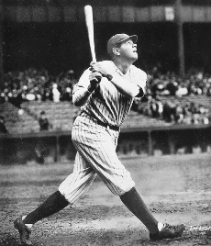BR
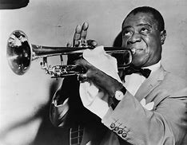LA
AE

Why was the cinema so popular? Complete the spider diagram below.

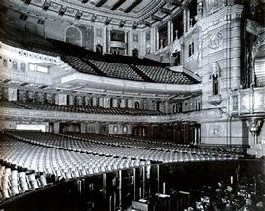

The following forms of entertainment below were world changing. Explain why each was so significant?
Entertainment | Significance
The Radio
Clubs and dancing
Jazz
Speakeasies
The gramophone
Baseball
Talkies
FADs
Q Which form of entertainment was most significant to American culture in your opinion?

Women
Use the spider diagram below to describe life for women before WW1?

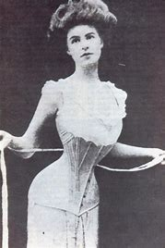

Why was WW1 significant as a catalyst for change for women in the USA?

Describe next to the picture how women’s lives had changed by the 1920s?
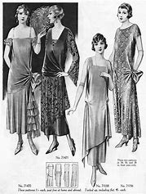

Why did some people dislike the changes? What reasons did they have?

In your opinion – Did life really improve for women in the 1920s?
Yes it did - agree | No it did not - disagree

Exam practice:
Plan the following question 5s:
- Immigration:
“My notion of the United States is that it was a grand, amazing, somewhat fantastic place – the Golden Country – huge beyond conception, very exciting. In America one could make pots of money in a short time even if you were only an ordinary workman. In America even the common people were ‘citizens’ and not ‘subjects’ as in many European countries.”
Written by Louis Adamic in his autobiography, who emigrated to the USA from Solvenia in 1913. His book ‘From Laughing in the Jungle’ was published in 1932.
To what extent do you agree with this interpretation about why people emigrated to the USA?
Agree with the interpretation: | Why does this person have this opinion? Who might disagree? (Origins)
Disagree with the interpretation – what other opinions would there be about this topic? | Conclusion – what do you believe?

- Race and Religion:
“The persecution and discrimination of black people in America was the most heinous crime that has been committed by a Federal State”
An article called ‘Racial Crimes in the 1920s’ in an academic website for American Studies, produced by the University of New York in 2017.
To what extent do you agree with this interpretation that the treatment of African-Americans was the worst crime committed by the American government in the 1920s?
Agree with the interpretation: | Why does this person have this opinion? Who might disagree? (Origins)
Disagree with the interpretation – what other opinions would there be about this topic? | Conclusion – what do you believe?

- Crime and Corruption

“In America in the 1920s deaths from cirrhosis of the liver fell from 29.5% per 100,000 in 1911 to 10.7% per 100,000 in 1929. Thus proving prohibition to be a resounding success.”

Written in a 2017 GCSE textbook called ‘The USA: A Nation of Contrasts 1910-1929’ by Steve Waugh, John Wright and R. Paul Evans.

To what extent do you agree with this interpretation that prohibition was a success?
Agree with the interpretation: | Why does this person have this opinion? Who might disagree? (Origins)
Disagree with the interpretation – what other opinions would there be about this topic? | Conclusion – what do you believe?

- Economic Boom
“9/10s of the goods bought annually by women, and so the advertising appeal must not ignore the first great quality of the heart which is love. There, in almost every advertisement is a reference in word or picture to mother love, to the home, to children, to sentiment.”
The manager of an advertising firm, speaking to his employees explaining how to appeal to women. He made these comments in 1926.
To what extent do you agree with the interpretation that advertising played a major role in the economic boom?
Agree with the interpretation: | Why does this person have this opinion? Who might disagree? (Origins)
Disagree with the interpretation – what other opinions would there be about this topic? | Conclusion – what do you believe?

- Economic Bust
“The number of inexperienced speculators is being increased by a great many men who have been attracted by newspaper stories. These amateurs have not learnt that markets sometimes panic and that there are large falls in prices.”
A businessman in 1928 warning about the dangers of over-speculation written in the New York Times and the Financial Times.
To what extent do you agree with the interpretation that over-speculation was the main cause of the Wall Street Crash.
Agree with the interpretation: | Why does this person have this opinion? Who might disagree? (Origins)
Disagree with the interpretation – what other opinions would there be about this topic? | Conclusion – what do you believe?

- Popular Entertainment
“The motion picture industry has achieved a standing and a size that makes it impossible for people studying industry to overlook it. It is already the fourth largest industry in the USA.”
From a speech to Harvard University students by J. P. Kennedy, an investor in the film industry in 1927.

To what extent do you agree that this was the most popular form of entertainment in 1920s USA?
Agree with the interpretation: | Why does this person have this opinion? Who might disagree? (Origins)
Disagree with the interpretation – what other opinions would there be about this topic? | Conclusion – what do you believe?

- Women
“The American woman has transformed into a liberal, happy, flirtatious and free-spirited individual. This flapper lifestyle has stretched from coast to coast, mountain to mountain and river to river.”
Written by the English journalist Jane Smith about flappers in the USA in 1921. The article was published by the Sun newspaper in London.
To what extent do you agree that all women benefitted from this new flapper lifestyle in the 1920s?
Agree with the interpretation: | Why does this person have this opinion? Who might disagree? (Origins)
Disagree with the interpretation – what other opinions would there be about this topic? | Conclusion – what do you believe?

