PiXL Independence:
Geography – Student Booklet
KS4

AQA Style, Economic Geography
Contents:
- Multiple Choice Questions

- Short Answer Questions

- Annotation

- Suggested Reading/Watching

- Long Answer Questions

- Synoptic Thinking

- Multiple Choice Questions

- HIC stands for

- Halfway Into Commercialising
- High Income Country
- Heavily Invested Country
- Human Innovation Centre

- A LIC is

- One of the poorer countries in the world
- A tropical country
- A country with port facilities

- A NIC (or NEE) is a country that is

- Getting poorer
- Getting richer
- Getting better infrastructure

- Quality of life is made up of

- Economic factors including income and job security
- Physical factors like diet, water supply and climate
- Social factors including health and education
- Psychological factors such as freedom and happiness
- All four of the above

- Development is

- How rich a place is
- The use of resources and technology to improve the standard of living
- How healthy a place is

- Which of these is a sign of development?

- Fragile food supplies
- Poor infrastructure
- A lack of health care
- Equal education availability for males and females

- The best measure of a country’s wealth is

- GDP
- GDP per person
- GDP per capita
- PPP (Purchasing Power Parity)

- Gross Domestic Product is

- The value of all the goods grown in a country
- The total value of all the things made in a country
- The total tax income
- The total value of goods and services produced in a country in a year

- GDP per capita is a better measure because

- It is more mathematical
- It is an average across the whole country
- It only considers people educated well enough to know Latin

- Two of the richest countries in the world by GDP per capita are

- Ethiopia and Sudan
- UK and France
- USA and Germany
- Norway and Qatar

- HDI is a development indicator that uses

- Wealth
- Health and Wealth
- Health and Education
- Health, Wealth and Education

- In the 1980s the world was split by the Brandt Line into

- A rich West and a poor East
- A rich South and a poor North
- A rich North and a poor South

- Least Developed Countries (LDCs) are the poorest of the Low Income Countries. How many of them are there?

- 7
- 17
- 32
- 49

- Low income countries tend to be

- Landlocked
- Small island nations
- Tropical
- Lacking natural resources
- All of these

- High income countries

- Have a high energy consumption
- Have a low energy consumption

- NGOs are significant Aid donors. NGO stands for

- Not Government Office
- Not Generous Offer
- Non-Governmental Organisation
- Nigeria Grant Officials

- The Primary Sector is

- Harvesting natural resources
- Manufacturing
- Services
- Using high technology to provide expertise

- The Tertiary Sector is

- Harvesting natural resources
- Manufacturing
- Services
- Using high technology to provide expertise

- The Secondary Sector is

- Manufacturing
- Harvesting natural resources
- Services
- Using high technology to provide expertise

- An example of a Quaternary job is

- Farmer
- Car maker
- Biotechnologist
- Nurse

- Subsistence farmers

- Grow cash crops
- Grow crops
- Grow enough to feed themselves
- Farm cattle

- In a HIC, the biggest employment sector is

- Primary
- Secondary
- Tertiary

- In a NIC, the biggest employment sector is

- Primary
- Secondary
- Tertiary

- In a LIC, the biggest employment sector is

- Secondary
- Primary
- Tertiary

- HICS have small numbers of people in Primary Industry because

- Technology replaces human labour
- Fields are very fertile
- Cows are bigger

- Top Down development …

- Makes money from a sunny climate
- Relies on money trickling down to poorer people
- Empowers the poorest people to change their lives

- TNC stands for

- Trading Nations Council
- The National Congress
- Trains and Cars
- Trans National Corporation

- Globalisation has helped HIC citizens by

- Creating jobs
- Providing cheap goods
- Improving employment rates
- Lowering interest rates

- Globalisation has not helped HIC citizens by

- Exporting jobs to LICs
- Providing cheap goods
- Countries have more control over their development

- Globalisation has helped NIC citizens by

- Providing cheap goods
- Giving access to great Western entertainment
- Providing employment alternatives to farming

- Short Answer Questions
Answers should be written in full sentences and use geographical terminology and good SpAG.
Be sure to respond to the question’s command word;
If the question asks you to describe, only give statements.
If the question says explain, make a point and then say why.
Be sure to use capital letters to start each sentence and for place names; SPaG carries marks.

Development
- Name three development indicators that you would use to classify a country.

- Describe the difference in industry between a HIC and a LIC.

- What is meant by the term “Sustainable development”?

- Describe the factors that have stopped some countries from developing. Name an example.

- How does the environment suffer as a country develops?

- If a country is landlocked it tends to be less wealthy. Explain why.

- There are more LICs in tropical areas than most other climate zones. Give three reasons why this might be.

- How does birth rate change with increasing development?

Measuring Quality of Life
- The United Nations uses Purchasing Power Parity to compare countries. Explain the advantages this measure has over GDP.

- The Human Development Index (HDI) is a way to measure development using three factors. Name those factors.

- HDI uses health, wealth and literacy. For each one, explain what a good figure implies about the usefulness of the Government.

- Some of the most developed countries (by HDI) have a high GDP per capita too. Explain why.

- Why do some geographers no longer use the Brandt Line to divide the world?

- Most atlases give calorie consumption per capita in their lists of development indicators. Justify the inclusion of such an indicator.

- The BRICs economies are NICs. Name them.

Aid
- Give three reasons why some countries need aid.

- Give three reasons why some countries give aid to other countries.

- Aid is often targeted at infrastructure, Explain why.

- Critics of aid argue that it isn’t sustainable. Give an example of where it has been and explain why.

Employment Structure
- Explain why most HICs have small primary sectors.

- Most LICs have large tertiary sectors. How does this benefit the lives of the people who live there?

- NICs develop through earning money through manufacturing. Give two reasons why it has worked for them.

- Most people in the UK have jobs in the formal sector. What are the advantages for them of being in the formal sector?

- Many people in LICs suffer for being part of the informal employment sector. Explain one way in which they are disadvantaged.

- How has automation and robotics changed the employment structure of the UK? Answer in fifty words and include the terms; replaced, improved and quaternary.

- What does the term “post-industrial” economy mean?

Globalisation
- Give three characteristics of a Trans National Corporation.

- Describe how the colonial powers of Europe started the development gap.

- Summarise how TNCs do business with HICs and LICs.

- Give an example of how globalisation has affected the world of entertainment.

- Dependency is when a region has little control over a TNC that is a major employer of their population. Why is it a bad thing?

- Manufacturing job numbers in the UK peaked in 1966. Describe what has happened to those areas most affected.

- Give reasons as to why the North of the UK has suffered more than the South from globalisation.

- Explain how globalisation has affected the environment.

- Annotation
Study the images and identify evidence, then explain that evidence.
Annotate is more than just label. You need to identify and then develop this further with an explanation as to why what you have pointed to is relevant to the question asked.
Study the image of Tokyo. Annotate it to explain how it shows Tokyo is in a High Income Country.

Study the image of a shop in Mombasa, Kenya. Annotate to (1) explain how it shows Kenya is a LIC and (2) how this photo shows the Informal Sector.

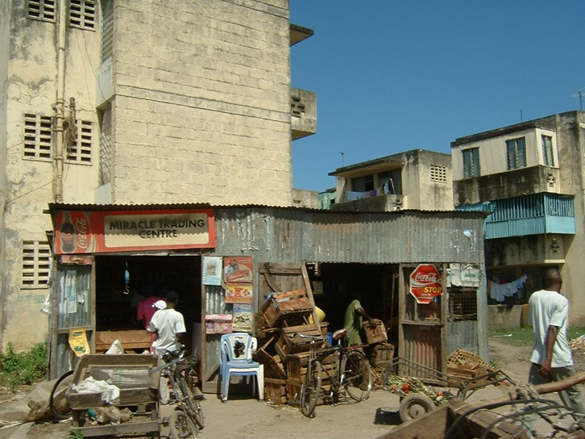

Study the image of rural Kenya. Kenya has a low GDP per capita ($1443) and a low HDI (0.555, 146th in the world). Annotate the photograph to show how this can be seen in the picture.

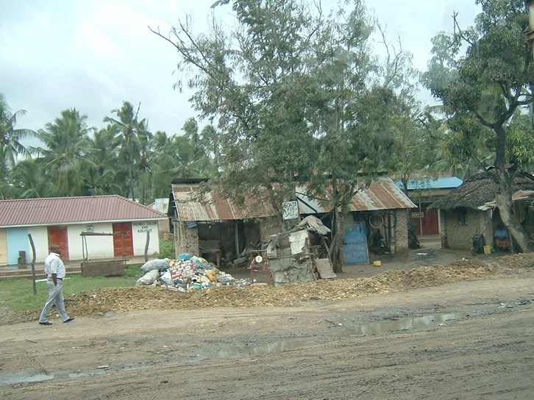

- Suggested Reading/Watching
- Employment structures

https://geographyfieldwork.com/EmploymentStructure.htm

- An example of large scale, bottom up Aid

http://www.bbc.co.uk/news/av/magazine-41391844/why-is-africa-building-a-great-green-wall

- A look at how health impacts development

https://www.youtube.com/watch?v=V35Vw29tay0

- A good guide to poverty and extreme poverty

https://www.youtube.com/watch?v=9MpVjxxpExM

- An overview of globalisation (bear with it through the “jokes”)

https://www.youtube.com/watch?v=s_iwrt7D5OA

- A detailed look at post-industrial regions

https://www.economist.com/news/leaders/21730412-time-fresh-thinking-about-changing-economics-geography-right-way-help-declining

- Scranton, PA is part of the USA’s post-industrial area. Read the article on the arrival of a new company and evaluate whether it offers value for money (jobs vs incentives)

http://citizensvoice.com/news/paper-bag-manufacturer-to-establish-facility-in-sugar-notch-1.2140551

- Amazon is looking to expand. This article is good for problems it has caused, yet how many cities are desperate to be the home of a new HQ?

https://www.nytimes.com/2017/09/07/technology/amazon-headquarters-north-america.html

- A simple introduction to sustainability

https://www.youtube.com/watch?time_continue=215&v=_5r4loXPyx8 or https://www.youtube.com/watch?v=B5NiTN0chj0

- An introduction to sustainable development

https://www.youtube.com/watch?v=7V8oFI4GYMY and https://www.youtube.com/watch?v=masQeEG5FX4

- More detailed discussion of sustainability

https://www.youtube.com/watch?v=39bPjnFBt-o

- Interesting thoughts on the Development Gap

https://www.youtube.com/watch?v=9-4V3HR696k

- A series of (progressively more complex) videos on the Millennium Development Goals

https://www.youtube.com/watch?v=9-xdy1Jr2eg&t=24s
https://www.youtube.com/watch?v=Q-HHIczsAGM
https://www.youtube.com/watch?v=9-xdy1Jr2eg
https://www.youtube.com/watch?v=o08ykAqLOxk

- Long Answer Questions
All answers should be written in full sentences and use geographical terminology.
Your answer should be approximately 150 words long and have a clear structure. Make sure for each point you make you have thought of P.E.E.L. (Point, Evidence, Explanation and Link). Make sure you have used real life examples which in turn have good detail as evidence to back up your points.
You should attempt to answer the longer questions on the following page using the following tips to help you with each set of command words:

Do you agree with this statement? Justify your reasons
- Read the statement.
- Come up with at least two reasons you could agree with the statement and at least two reasons you could disagree.
- Now find some evidence to back up these reasons.
- Now write the answer using the following structure:
  - Reasons you agree, reasons you disagree, overall conclusion on your outcome.

Compare
- Consider what is similar about the two things you have been asked to compare.
- Consider what is different about the two things you have been asked to compare.
- Now write your answer using the following structure:
- Similarities, differences, overall summary.

Assess the extent to which/To what extent?
- Read the statement after “Assess the extent to which/To what extent?”
- Decide where you sit on a sliding scale - do you totally agree with the statement or totally disagree? (you are best to sit somewhere in the middle!)
- Consider your reasons for agreeing or disagreeing.
- Now find some evidence to back up the reasons you have come up with.
- Now write the answer using the following structure:
  - Reasons you agree, reasons you disagree, overall conclusion on your outcome.

Evaluate the effectiveness of
- Consider what is effective about the question topic.
- Consider what is ineffective about the question topic.
- Now write the answer using the following structure:
  - Reasons you think it is effective, reasons you think it is not effective, overall conclusion on the effectiveness.

Explain
- Consider the in-depth reasons for the question topic (the how and why).
- Make sure you have at least four reasons (points) you could discuss.
- Structure your answer explaining and expanding your points, one point per paragraph.

Questions:
- Using examples, suggest why some countries or cities have encouraged manufacturing businesses to their area.

- Analyse the reasons why some countries are more developed than others.

- Using an example/s you have studied evaluate how tourism can improve the development of a country or region.

- To what extent is globalisation helping LICs develop?

- "Globalisation has been an overwhelmingly positive for the world". Use evidence to support this statement.

- "The Brandt line is no longer valid". To what extent do you agree with this statement?

- Assess the benefits of top down development.

- Using an example of an industry you have studied, evaluate its impact on the environment.

