[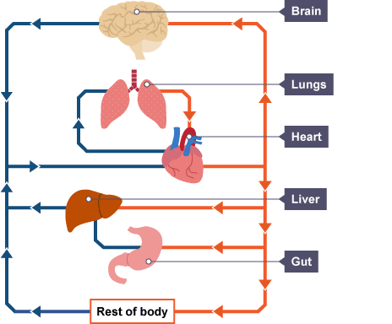](https://www.google.co.uk/url?sa=i&rct=j&q=&esrc=s&source=images&cd=&cad=rja&uact=8&ved=0ahUKEwjZyuq-zbLZAhXDY8AKHZHEC6MQjRwIBw&url=http://www.bbc.co.uk/schools/gcsebitesize/science/triple_ocr_gateway/the_living_body/circulatory_systems_cardiac/revision/2/&psig=AOvVaw1m9pB32fwavlKMlc3xNvvO&ust=1519151211812536)