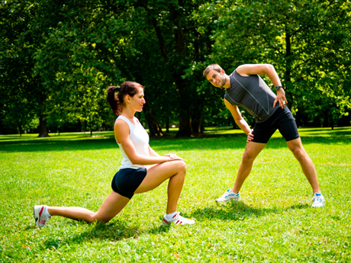
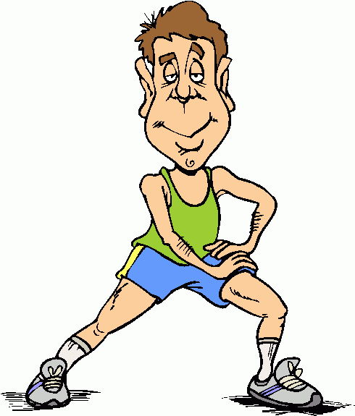
Homework:
Design a warm-up and a cool down for your chosen sport

Warm up: Create a warm-up that will include movements, actions and activities that meet the five components of an effective warm-up? (Some activities may meet the demands of the two options).

-

-

Cool-down: Create a cool down that includes the components of a cool down (write the specific things you would do, don’t just put stretches).

-

-

Extension task: On the back of this worksheet can you include the benefits of the warm up and the benefits of the cool down.
Physical benefits of a warm up: | Physical benefits of a cool down:
1. | 1.
2. | 2.
3. | 3.
4. | 4.

