[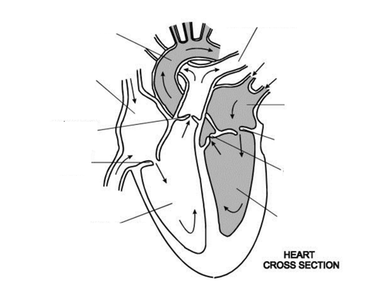](https://www.google.co.uk/url?sa=i&rct=j&q=&esrc=s&source=images&cd=&cad=rja&uact=8&ved=0ahUKEwjUjOG845DZAhVJ1hQKHSA9BGUQjRwIBw&url=https://www.tes.com/teaching-resource/human-heart-6297475&psig=AOvVaw0Z-dcM385jI0ucScTV0-s-&ust=1517988780850452)