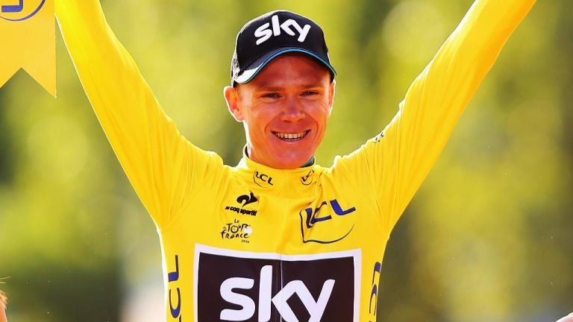

Chris Froome
Tour De France Cyclist

 |  | Food Groups | Justification
Breakfast
Lunch
Dinner
Snacks
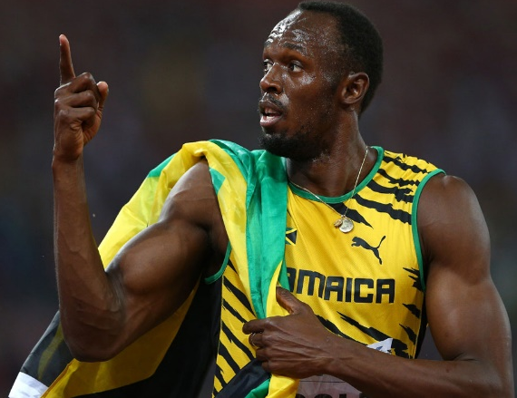

Usain Bolt
100m/200m/4X100m Relay Runner

 |  | Food Groups | Justification
Breakfast
Lunch
Dinner
Snacks

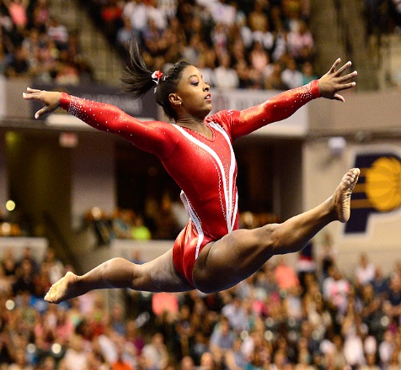
Simone Biles
USA All-round Gymnast

 |  | Food Groups | Justification
Breakfast
Lunch
Dinner
Snacks

Exam Questions
- What are the clear differences between the three athlete’s diets? Why is this? (4 marks)

- How does your diet compare to the athletes? What are the main differences? (4 marks)

- What food group would an endurance athlete predominantly eat when leading up to a big competition/race and why? (4 marks)

- What are the consequences of consuming too much fat in your diet? (5 marks)

