 | Arteries | Veins | Capillaries
Function / Direction of blood flow
Image of vessel
Structure/Thickness of walls
Lumen Diameter
Values
Pressure
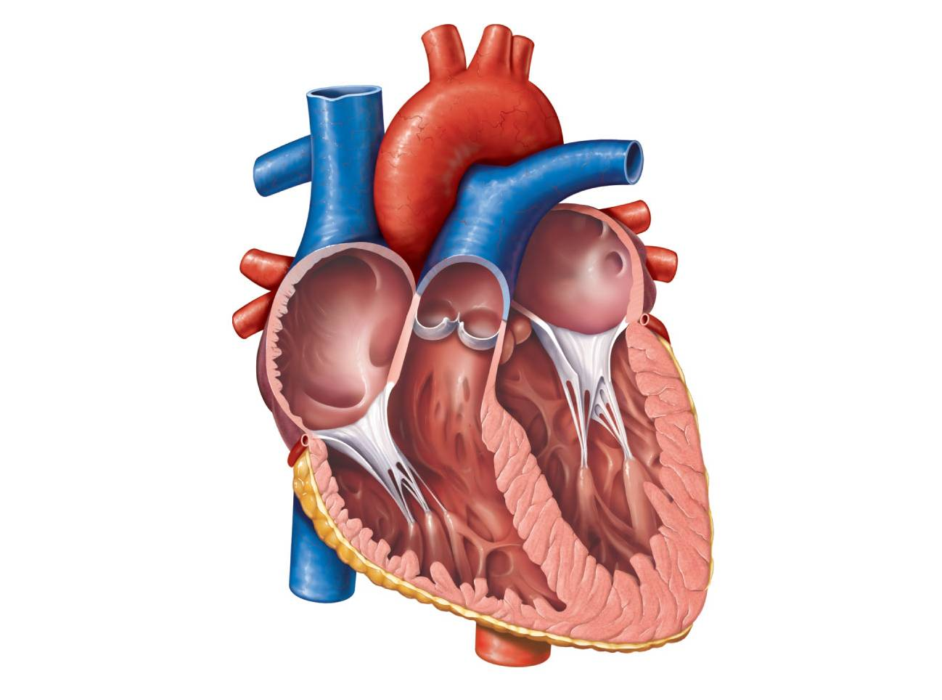
Please label the heart and identify which are arteries and veins.

