Movement Analysis

- What is a plane of movement? (1)

- What is an axis of rotation? (1)

- What are the three planes of movement that pass through the human body? (3)

- What are the three axes of rotation that pass through the human body? (3)

- Match the planes of movement with the correct description (3).
Plane |  | Description |  | Horizontal/Vertical
Frontal |  | Divides the body into the left and right hand sides |  | Horizontal
Transverse |  | Divides the body into the top and bottom |  | Vertical
Sagittal |  | Divides the body into front and back parts |  | Vertical

- Complete the table identifying and describing the three axes of rotation. (4)
Frontal
Imaginary line that passes from top to bottom through the performer’s centre of mass.

- Fill in the missing words from the table below (some words are repeated). (7)
Movement in physical activity and sport can be described using a series of ………………… and …………………. There are ………………. planes of motion that pass through the human body. These are called the …………………….... plane, the ……………………….. plane and the …………………………….. plane. This plane divides the body into ……………….. and ………………. parts. The frontal plane divides the body into front (…………………………) and back (………………………) parts. The transverse plane lies ………………………………. and divides the body into top (……………………….) and bottom (…………………………) parts. This plane is also sometimes referred to as the horizontal plane.
An axis is an imaginary ……………………… line around which a body or body part rotates. Movement at a joint takes place in a plane about an axis. There are ………………………. axes of rotation. The ………………………….. axis passes horizontally from ……………………. (posterior) to ……………………… (anterior). The …………………………… axis passes …………………………. from left to right. The ………………………………… axis is also known as the vertical axis and passes vertically from the bottom (inferior) to the top (superior).

planes | Transverse | posterior | right | Horizontally
anterior | Three | longitudinal | frontal | back
superior | Sagittal | horizontally | three | straight
transverse | Inferior | left | front | axes
 |  | Frontal

- Label the planes of movement (3).
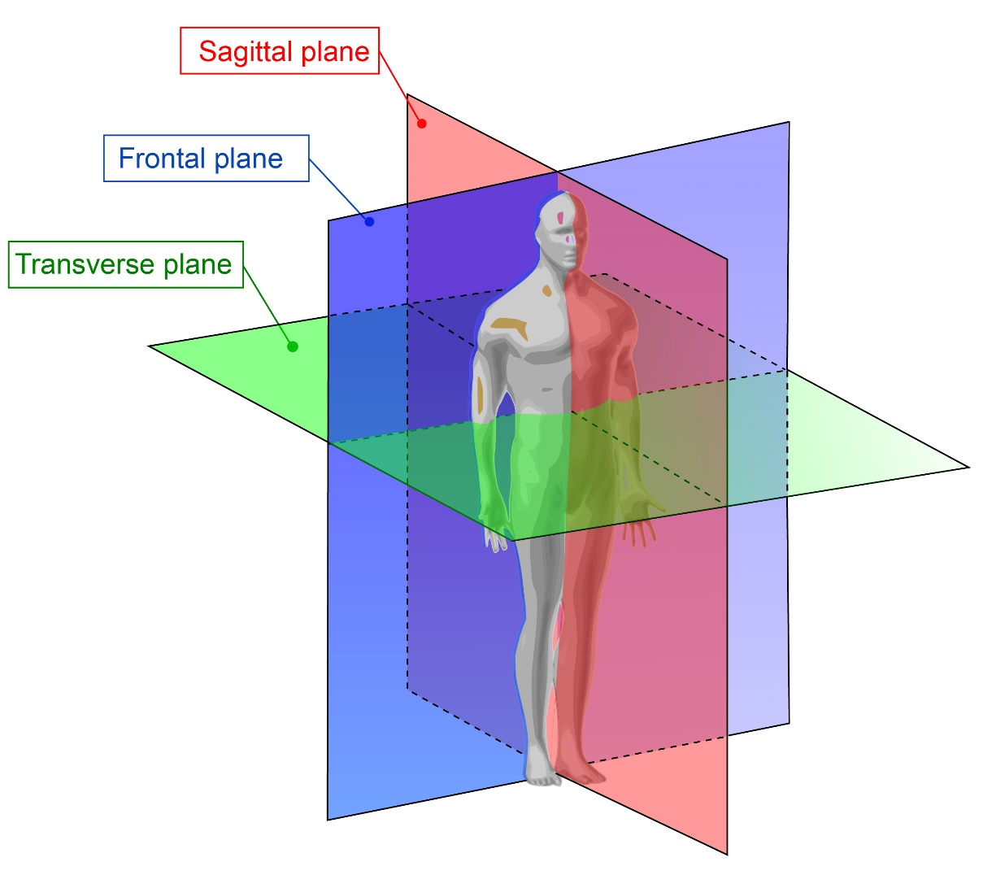

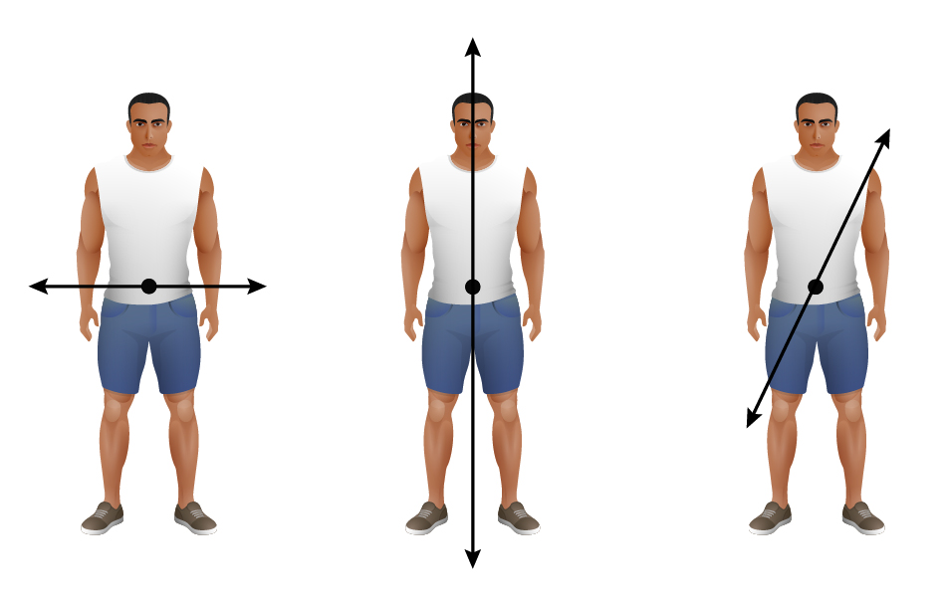
- Label the axes of rotation. (3)
/28

