

G.C.S.E

PHYSICAL EDUCATION

HOMEWORK

TOPIC: 1.2.2

A HEALTHY, ACTICE LIFESTYLE AND YOUR CARDIOVASCULAR SYSTEM

MARK | % | GRADE | IL
/ 29
COMMENTS:

A* | A | B | C | D | E | F | G | U
90% | 80% | 70% | 60% | 50% | 40% | 30% | 20% | 10%

NAME: ________________________________________________________

GCSE PE TEACHER: ____________________________________________

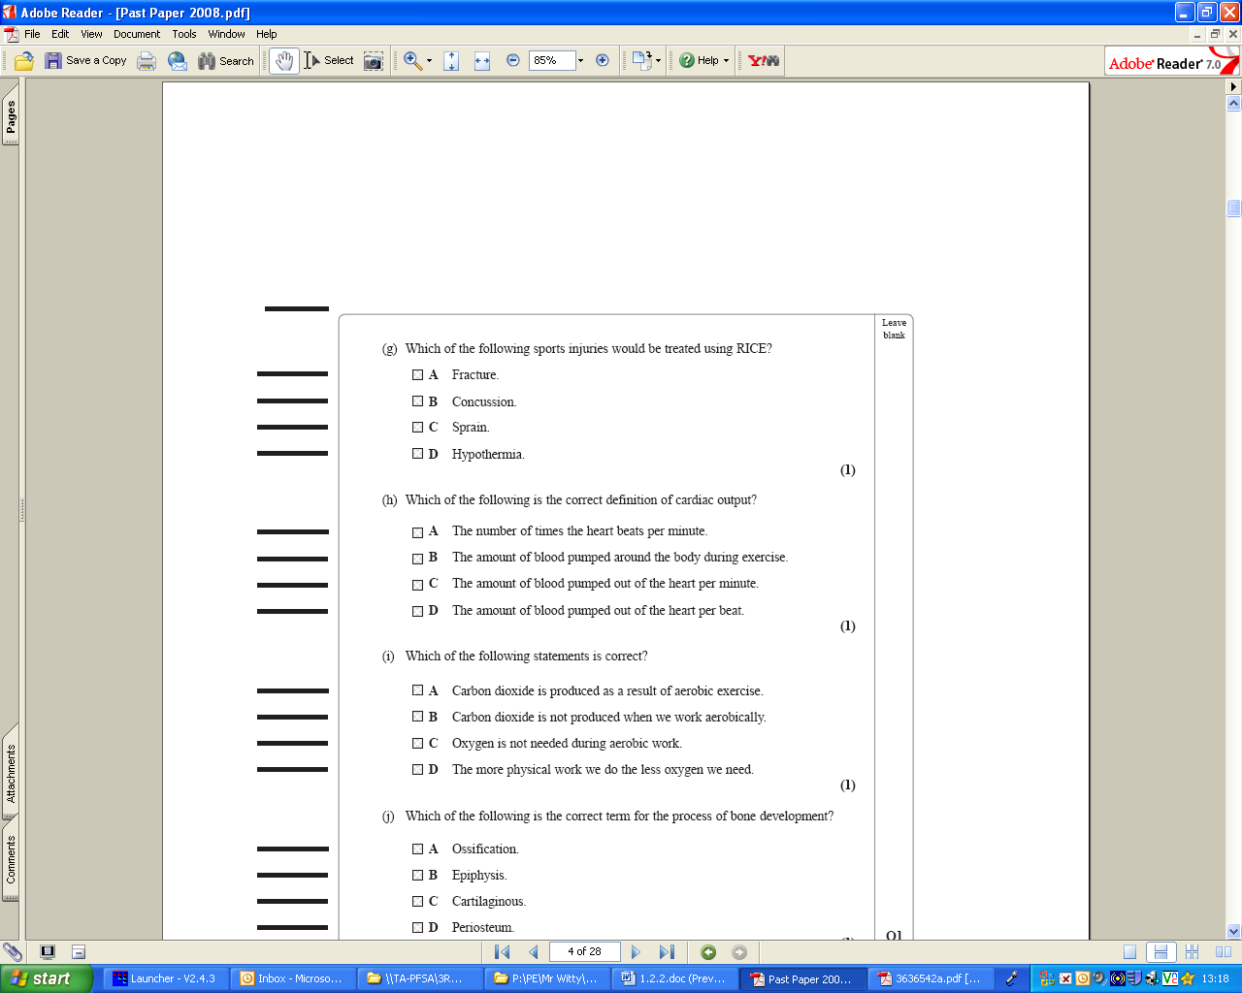

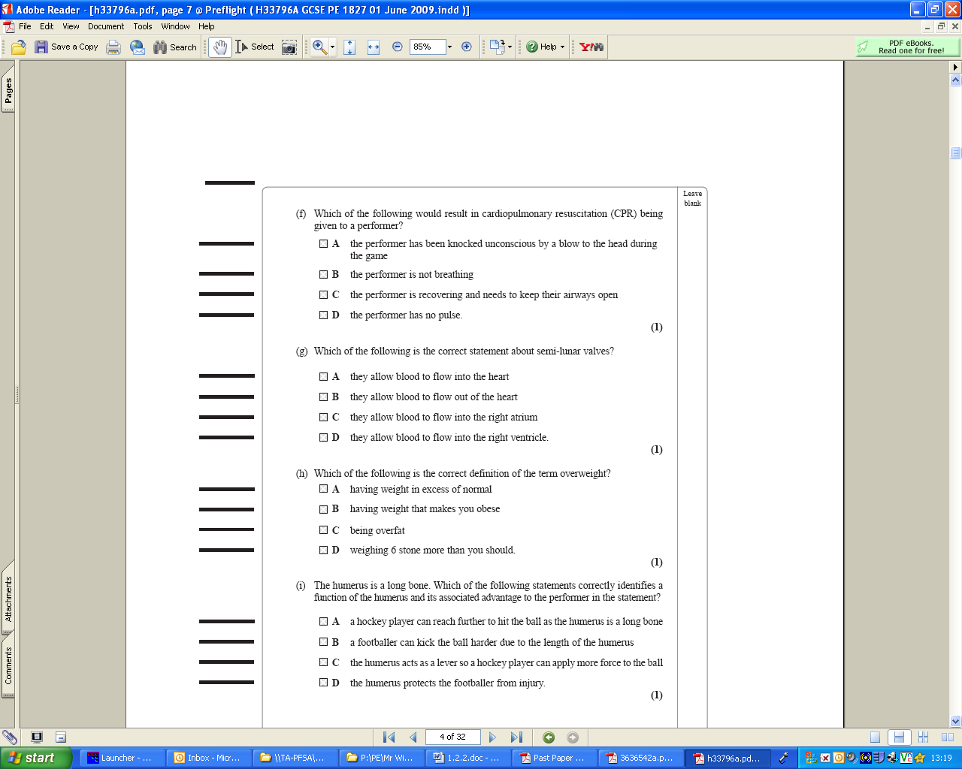

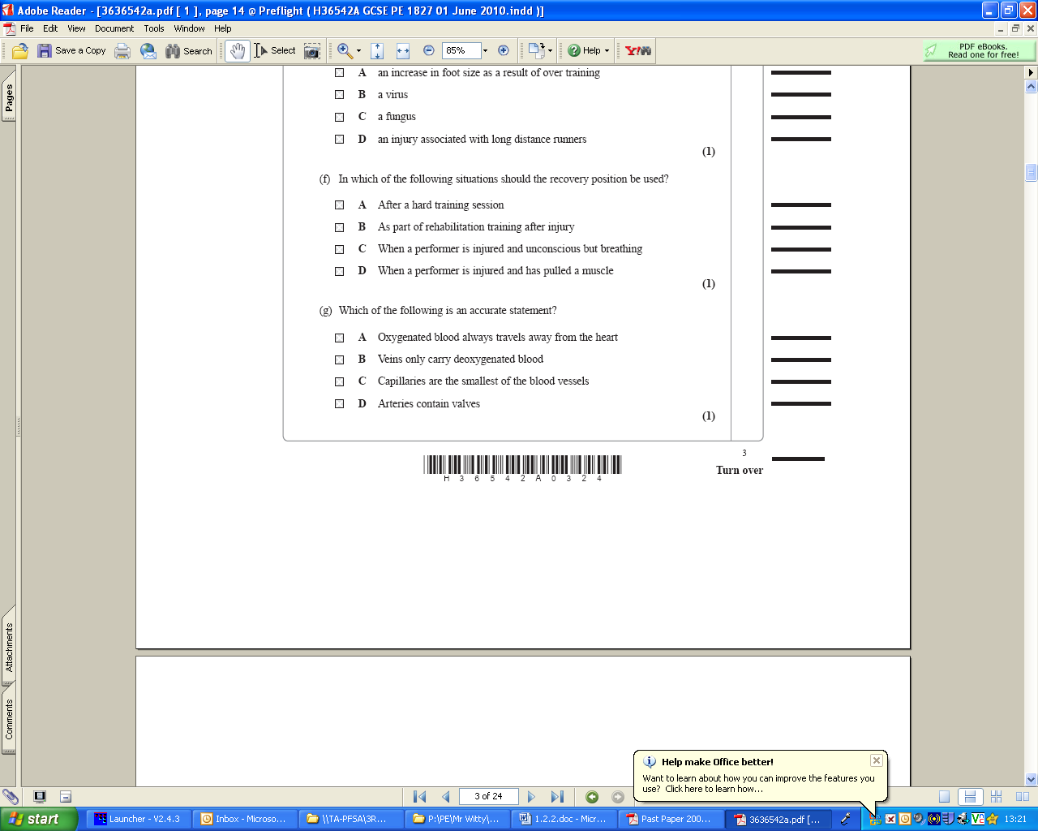
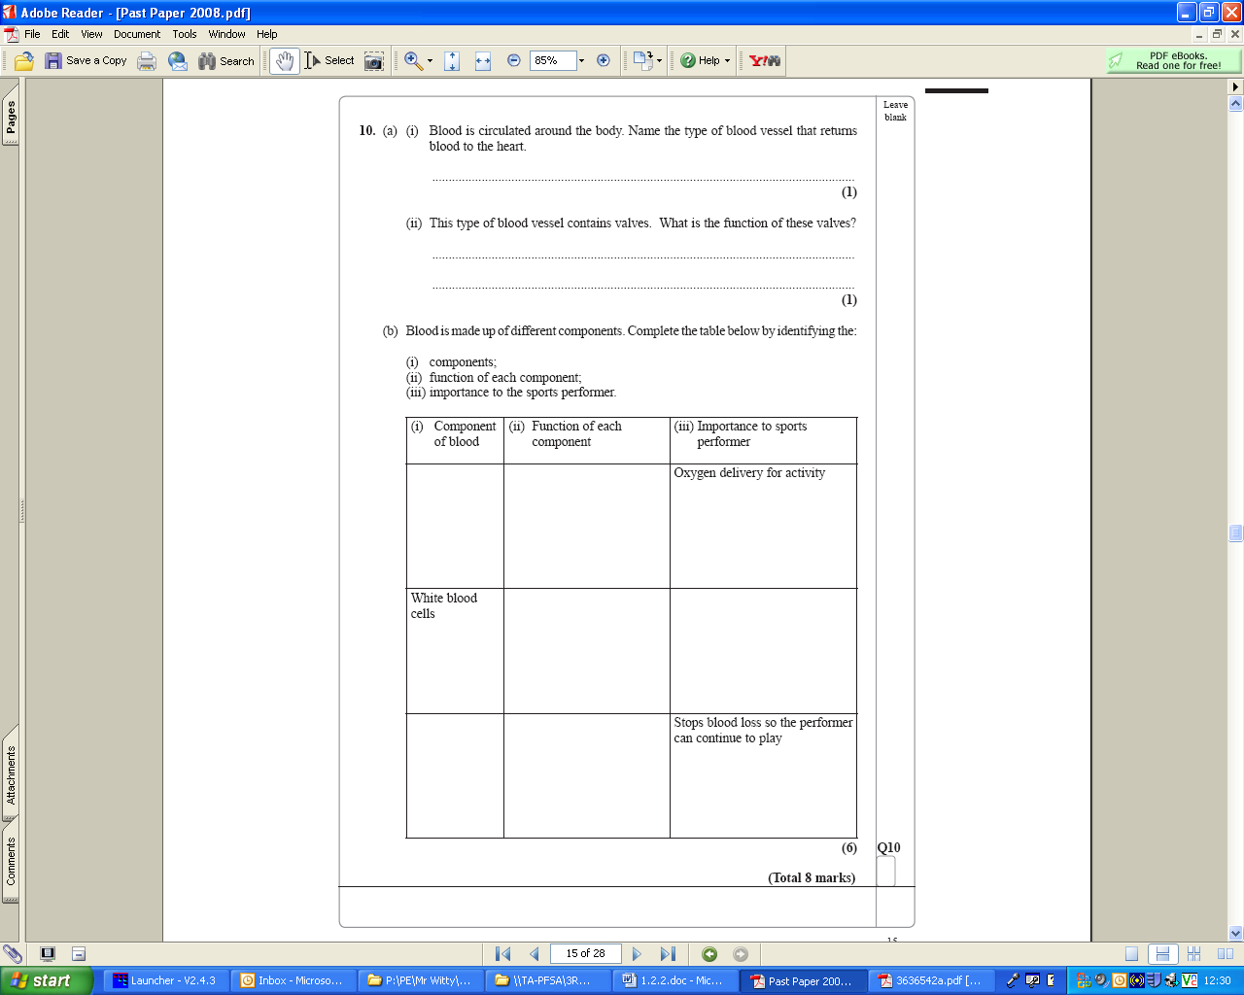

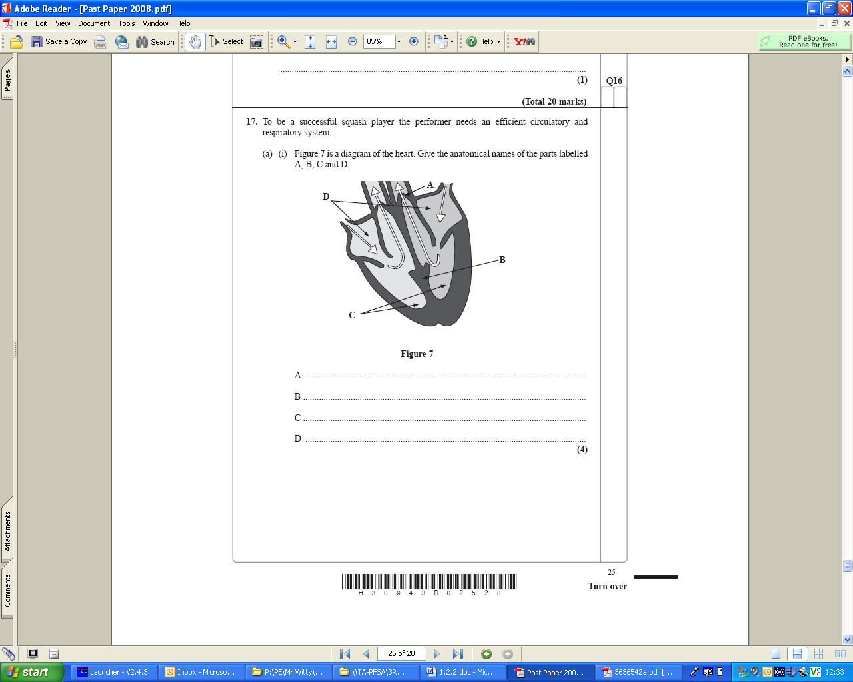

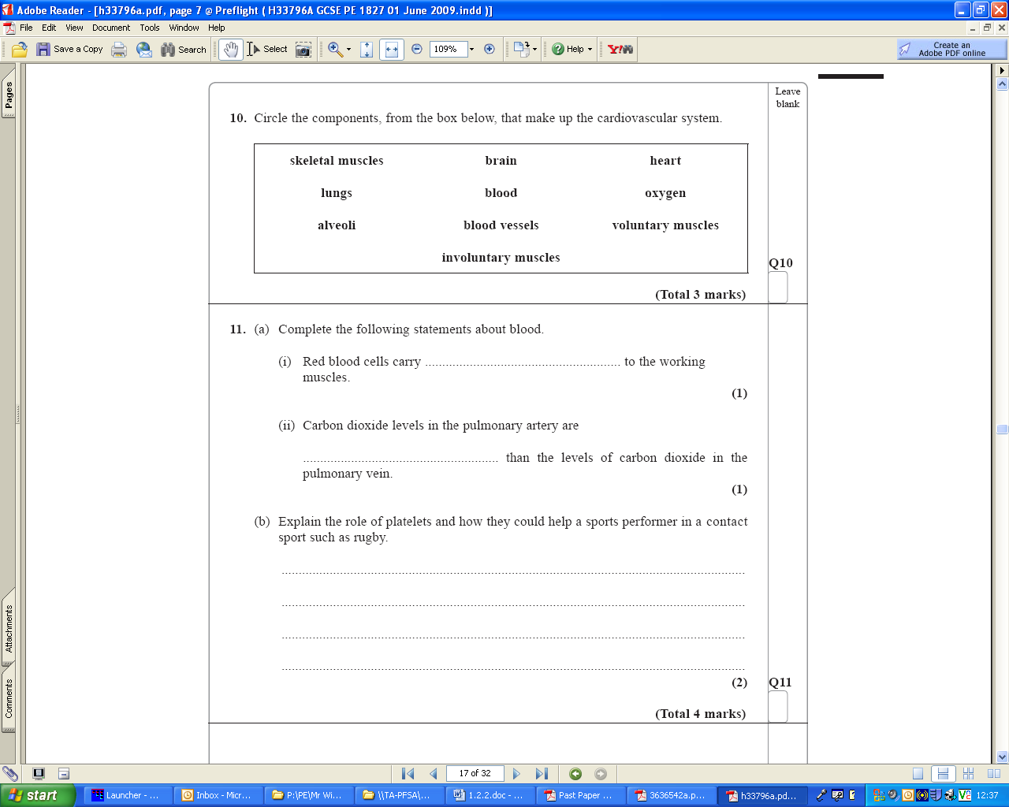

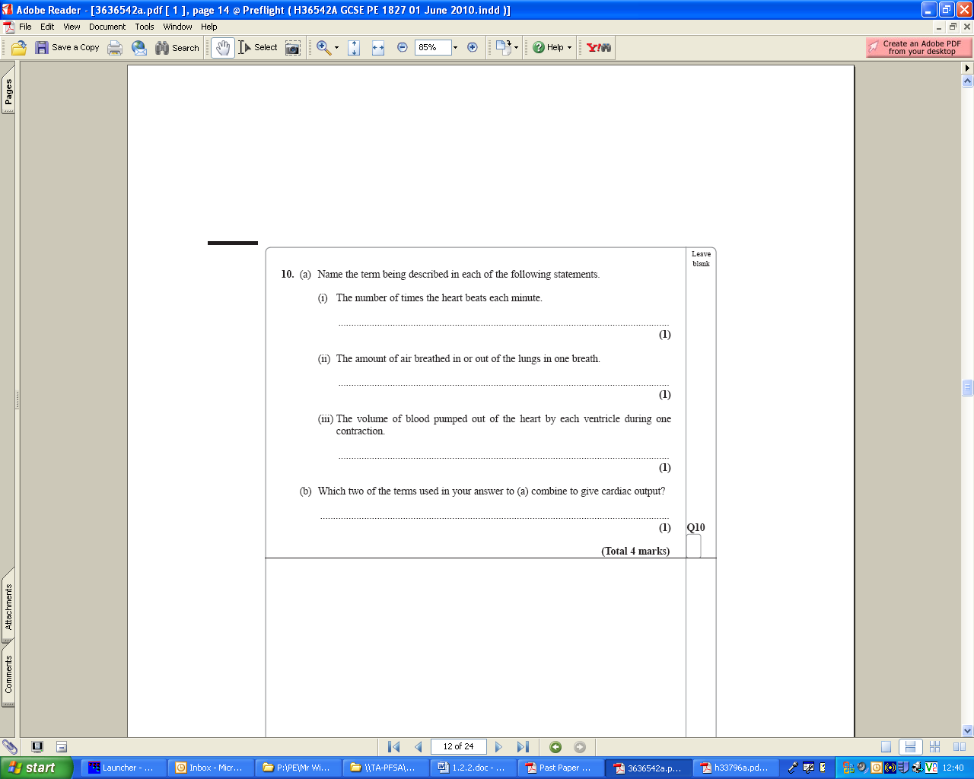

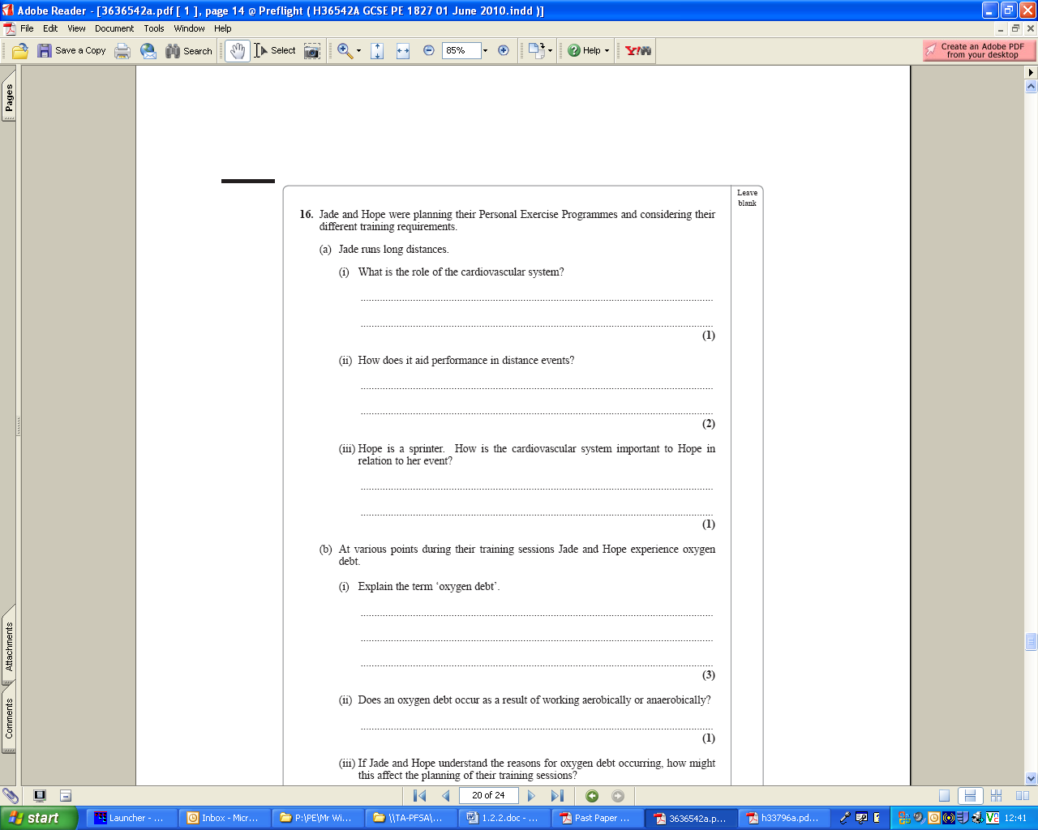

Student → Teacher Feedback:

CIRCLE A FACE | WHY?
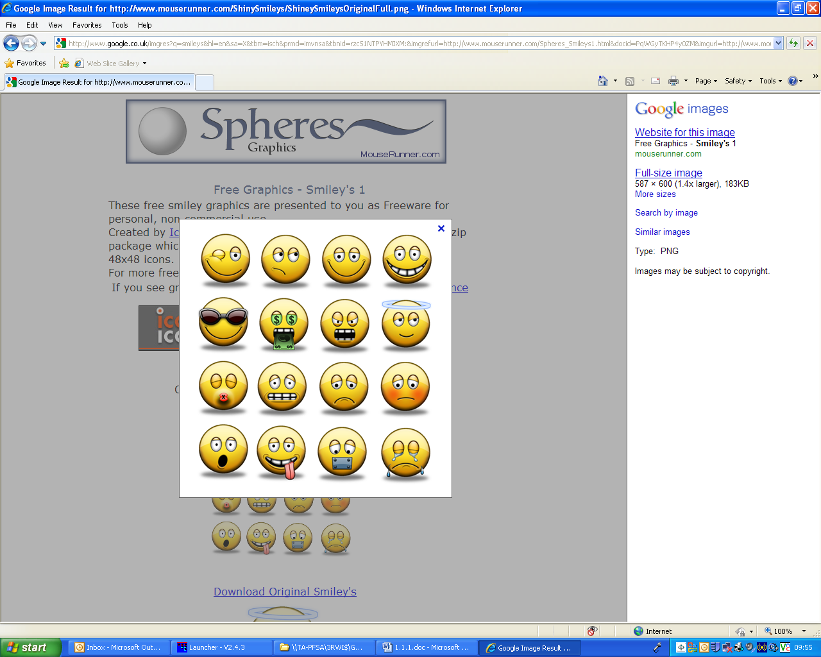 | I am confident with these parts of the topic..........
 | I am unsure about these elements of the topic..........
 | I am struggling with the following parts of this topic..........

