English Department – KS3 Homework
Year: 7 Term: T2A Scheme of Work: Descriptive Writing

 | PREPARE | CONSOLIDATE | DEEPEN | ABOVE AND BEYOND
List of Tasks: Complete 3 across the term  You must complete one from each column. | Create definitions for the different methods of figurative language that your teacher will give you | Create a short description using the senses/figurative language to describe effectively | Create a piece of writing that uses a flashback idea. Maintain the correct tense throughout | Create a short story that includes the following:  Non-linear narrative structure (using a flashback/flash forward/ dual narrative)  A complex and wide range of vocabulary and punctuation (! , : ; - …)  One sentence paragraphs used a an atmosphere shift
 | Create a character description of a character from a novel or film. Can you ‘paint a picture’ of them? | Plan your response for two short stories using the box method on the reverse of this task sheet.  Use the image labelled CONSOLIDATE 2 as a stimulus for your plan. | Find two examples of pathetic fallacy being used in writing and explain what imagery it conveys, what atmosphere is created and how it makes you feel. Replicate that in your own 150 word description.
Support Homework | Sort the examples on the sheet into two categories: similes and metaphors | Fill out the punctuation and sentence structure worksheet | Find something around your house that you can describe using the 5 senses. Don’t say what it is, let us guess!

Your teacher will direct you to complete the appropriate tasks, with specific deadlines. Make a note of which tasks have been completed over the course of a Scheme of Work

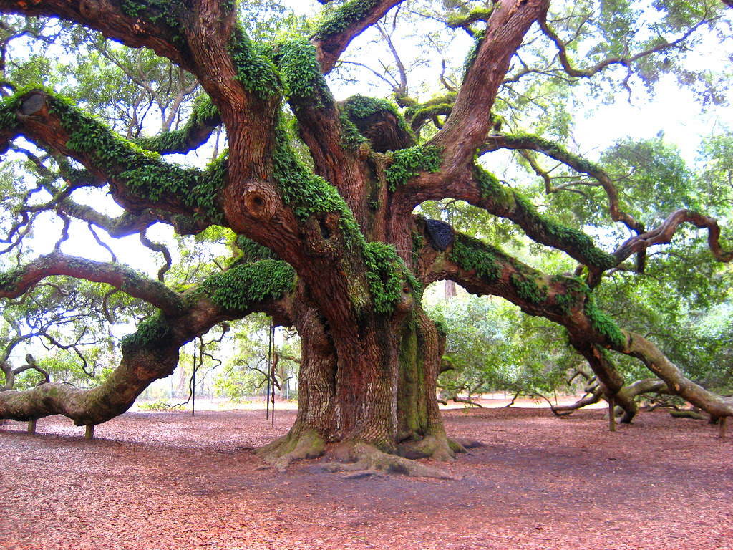

Imagine you are out for a walk in the woods one day when all of a sudden you come across this gnarled tree. You start to take slow, steady steps towards it when you hear a sudden click, like a lock being undone. A small door appears to open on the side of the tree and you can see a definite light glowing from within …

Write an imaginative story about what could happen when you come across this tree.
- Look to include a range of description, action and dialogue.
- Use lots of ambitious words for description.
- Use a range of connectives to link your sentences.

Paragraph | Focus | Content
1
2
3
4
5
6
Consolidate 2:
