English Department

AQA GCSE English Language
Revision Guide

This revision guide is designed to give you all of the information you need to prepare you for your English Language GCSE. Just reading this will not be enough to adequately prepare you, and you must DO something with it, for example:

- Make revision resources, posters, flashcards etc.
- Complete the tasks to revise the content and knowledge (eg. Subject terminology)
- Practice questions within the time limits specified.

Top Tip: KNOW THE PAPERS!

Language Paper 1 – Explorations in Creative Reading and Writing

The aim of this paper is to engage students in a creative text and inspire them to write creatively themselves by:
- In section A, reading a literature fiction text in order to consider how established writers use narrative and descriptive techniques to capture the interest of readers
- In section B, writing their own creative text, inspired by the topic that they have responded to in section A to demonstrate their narrative and descriptive skills in response to a written prompt, scenario or visual image.

Language Paper 2 – Writers’ Viewpoints and Perspectives

The aim of this paper is to develop students’ insights into how writers have particular viewpoints and perspectives on issues or themes that are important to the way we think and live our lives. It will encourage students to demonstrate their skills by:
- In section A, reading two linked sources from different time periods and genres in order to consider how each presents a perspective or viewpoint to influence the reader
- In section B, producing a written text to a specified audience, purpose and form in which they give their own perspective on the theme that has been introduced to them in section A.

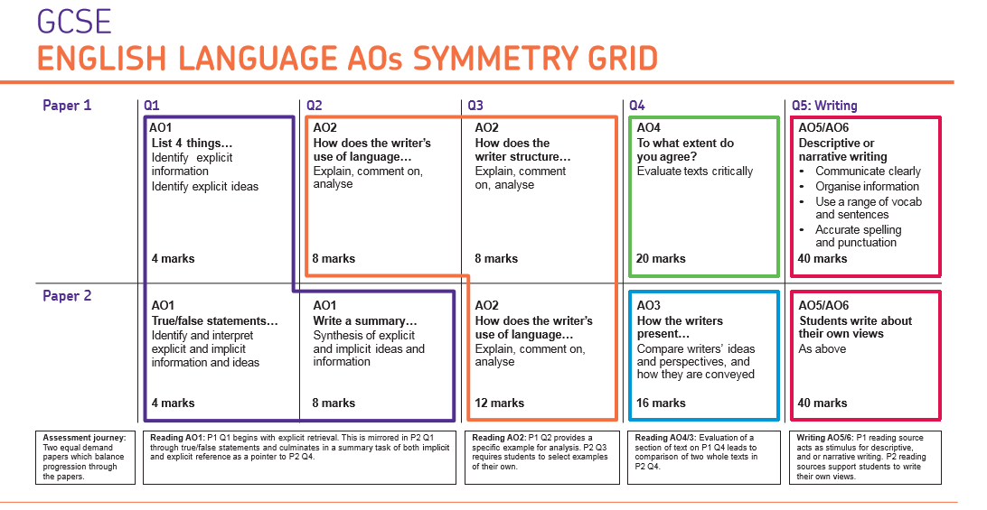
This grid demonstrates the question stems, mark allocation and most importantly, the SKILLS being assessed over the two papers. Ensure you are very aware what you must do in order to meet the demands of each question.
Active Reading
It is very important to read the texts carefully that you are being examined on. Ensure you have a clear understanding of what the texts are about in order to answer the questions carefully.

How to actively read:
- Read the WHOLE text. Identify the type of text it is, the purpose of the text, and who the potential audience is.
- Read the question carefully, identifying what exactly it is that you need to do.
- Re-read the text with a highlighter, identifying key information which allows you to answer the question.

Also, use ALL of the information available to you. In both papers, the sources have information about when they were produced and by whom, as well as a ‘blurb’ telling you about the context of how the text was produced.
This information will allow you to establish where the text has come from, and allow you to work out the perspectives of the writers.

Language Paper 1 – Explorations in Creative Reading and Writing

Understanding and prioritising your timing in these exams is crucial

Read the text – ensure that you are very clear what the text is about, and start to think about the linguistic and structural features. (5 minutes)

Question 1: List four things from the text… [4 marks] (5 minutes)

Question 2: How does the writer use language to… [8 marks] (12 minutes)

Question 3: How has the writer structured the text to… [8 marks] (12 minutes)

Question 4: Based on an opinion about the text, To what extent do you agree? [20 marks] (25 minutes)

Question 5: Write a descriptive narrative based on the options – a visual stimulus, or a written task. [40 marks] (5 minutes planning + 40 minutes writing)

You MUST take ownership of this, and be prepared. You won’t know the text, but will know all of this.

Language Paper 1 – Explorations in Creative Reading and Writing
Question 1

This is a fairly straightforward information retrieval question.
- Identify implicit and explicit information from the text.
- 4 marks – so 4 correct statements, accurately expressed.
- AO1 - Identify and interpret explicit and implicit information and ideas.
- Ensure that the information can be supported by the text – be careful that what you write answers the question. You can use quotations if necessary.

Top tip – ensure you write in clear statements / sentences, rather than just ‘ideas’.

Language Paper 1 – Explorations in Creative Reading and Writing
Question 2

This question wants you to explain and analyse what the effects of the language are within the extract, describing a specific focus.
- Produce an analysis of the language used within a specific part of the text – ensure you focus on the part of the extract the question asks for.
- 8 marks – so 2-3 detailed explorations of language.
- AO2 - Explain, comment on and analyse how writers use language and structure to achieve effects and influence reader, AND use relevant subject terminology to support their views
- Focus on words and phrases, as well as specific language features. The main focus needs to be on the effects of language.
Top tip – when explaining the effects of specific choices of language the writer has made, explain what the words / phrases make you think, feel and imagine.
AO2 – Subject terminology
TASK: Language features found in fictional texts – identify the definition and the effect of these specific features
Language feature / device / technique | Definition / Effect
Simile

Metaphor

Personification

Alliteration

Rhetorical question

Power of 3

Sensory language

Pathetic fallacy

Dialogue

Narrative voice

Specific diction

Semantic field

Oxymoron

Emotive Language

Repetition / Anaphora
Juxtaposition

Language Paper 1 – Explorations in Creative Reading and Writing
Question 3

This question wants you to produce an analysis of the structure used throughout the whole extract.
- Produce clear understanding and explanation of the ways in which the writer has structured the text in order to interest and engage you as a reader.
- 8 marks – so 2-3 detailed explorations of the extract in terms of its whole structure.
- Use the bullet points in the question as a means of structuring your answer…

- How does the extract start? What does the writer focus on? Why do they do this?
- How and why does this focus change? Focus on the WHOLE text – how does it begin and how does it end, and what happens in between? Again, why has the writer done this?
- Look for any other structural features – eg. Repetition, short / long sentence types, juxtaposition, or links between the beginning and the end.
- Whenever writing about the structure, focus on WHAT, WHERE, WHY. WHAT is the writer doing / focusing on / describing, WHERE have they chosen to do this within the text as a whole, and WHY have they made this choice?
AO2 – Subject terminology
TASK: Structural features found in fictional texts – identify the definition and the effect of these specific features

Structural Feature | Definition / Effect
1st person narrator

3rd person narrator

Omniscient narrator
Introspective narrator

Chronological

Flashback

Foreshadowing / foreboding

Exposition

Climax

Resolution

Protagonist

Perspective

Juxtaposition

Repetition

Narrator

Contrast
Shift / change in perspective / tone / voice
AO2 - Top Tip…
Avoid ‘empty’, vague, generalised comments. If your comment on effect can be used in any context, it is not specific enough.

Do NOT use…
‘Has an effect on the reader…’
‘Hooks / draws the reader in…’
‘Tells us more about the story…’
‘Makes the reader want to read on…’
‘Uses language to emphasise.’
‘Creates an images in the reader’s head’
‘Makes the reader understand more clearly’

…These don’t mean anything!

Instead, be specific about the choices the writer has made. Use…
‘Has a ____________ effect on the reader, by…’
‘Intrigues / engages the reader by…’
‘Tells us that the character / setting / weather is…’
‘Evokes a _____________ response from the reader…’
‘Creates an image of _____________ through…’

Language Paper 1 – Explorations in Creative Reading and Writing
Question 4

This question wants you to produce an evaluative response to the statement in the question, using evidence and explaining to what extent you agree. This is worth 20 marks (25% of the whole paper), so you MUST leave enough time to answer it.

The process…
- Read the question carefully – what specifically in the statement does it need you to focus on? DON’T SKIP OVER ANYTHING.
- Actively re-read the text, identifying evidence which allows you to formulate an opinion on the statement. Identify 4 pieces of textual evidence.
- Look at the evidence and decide how far you agree with the statement based on what you have found. Produce a statement which closely links to the question.
- Write about each piece of evidence in turn, always focusing on the task and the writers’ methods.

How to structure this response:
- POINT in relation to task. (How far you agree)
- EVIDENCE which you’ve selected. (Embed quotations which support your ideas)
- EXPLAIN how it answers the question and the effect it creates. (AO2 – language analysis)

Top tips…
Always ensure you focus on the key words in the question – it will want you to ensure that ALL of your response focuses on the statement given.
Plan your response before you write it, identifying the evidence you will use, and how it answers the question.

Language Paper 1 – Explorations in Creative Reading and Writing
Question 5 (Section B)

Question 5: Write a descriptive narrative based on the options – a visual stimulus, or a written task. [40 marks]
(5 minutes planning + 40 minutes writing)

This task needs you to demonstrate the quality of your writing, in a creative and descriptive context.

The main things you must include to meet the demands of the task are:
- A range of linguistic features / techniques, crafted for effect.
- Language which clearly matches the task, audience and purpose.
- Extensive and ambitious vocabulary.
- Varied use of structural features (sentence forms, paragraphs, overall textual structure etc.)
- A range of developed and detailed ideas.
- Fluently linked paragraphs.
- Wide range of punctuation accurately and for effect.

Be careful… to do as the task says! If you choose the description, then produce a description of what it asks for, not a story. If you choose the story / narrative task, then produce a story using an appropriate structure. Don’t lose unnecessary marks by not adhering specifically to the task.
Language Paper 1 – Explorations in Creative Reading and Writing
Question 5 (Section B)

Language features
Ensure you use all of the different language features that you know about when writing descriptively, just like you have analysed in Section A!

YOU must create your own method of remembering these different language features. How could you do this through an acrostic, or acronyms (such as AFOREST)?

Language Paper 1 – Explorations in Creative Reading and Writing
Question 5 (Section B)

Structural Features
Ensure you use a logical and detailed structure when writing your response, if it is the description task, or the story / narrative. You must ensure that you:
- PLAN your response – what is a logical order for your content?
- Use clear paragraphs, with clear connectives / discourse markers.
- Experiment with paragraph structure – using repeated, one-line paragraphs or short paragraphs for effect.

If you are producing a story, ensure you have a clear and appropriate structure:
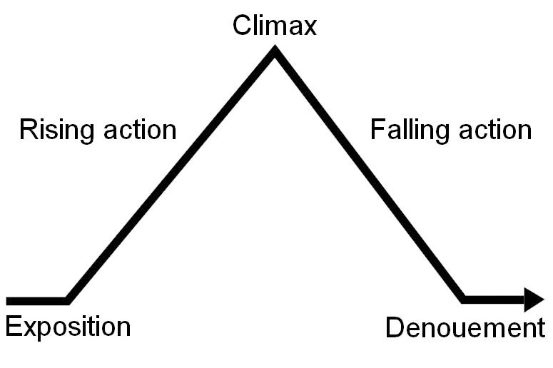

Remember, you won’t necessarily do an entire story, but it must have a clear, developed, appropriate structure.
Language Paper 1 – Explorations in Creative Reading and Writing
Question 5 (Section B)

Top Tip – have a ‘pre-planned’ structure which you can then fill in in terms of content which is specific to the task. For example, start with the weather, then the setting etc.

As an example…
Paragraph | Focus | Content
1 | Weather
2 | Setting
3 | Introduction of character
4 | Character faces conflict
5 | Introduction of second character
6 | Interaction of characters leading to climactic event

Produce your own plan, which can be applied and adapted to whatever task you may have.

Language Paper 1 – Explorations in Creative Reading and Writing
Question 5 (Section B)

Technical accuracy is important! This constitutes 20% of your marks per paper. To ensure that you are achieving high marks for technical accuracy, you must…

- Write in ‘proper’ sentences - Capital letters and full stops. NO EXCUSES!
- Use a wide range of punctuation accurately and for effect - . , ! ? … ; : ( ) “ ” -
- Use all different sentence types – simple, compound, complex, short, one-word – and ensure they are varied for effect.
- Ensure grammatical accuracy in sentence construction.
- Ensure spelling is as accurate as possible.
- Ensure you word choices are ambitious, sophisticated and varied.

How can you ensure that your technical accuracy is as accurate as possible?

Language Paper 2 – Writers’ Viewpoints and Perspectives

Understanding and prioritising your timing in these exams is crucial

Read both of the texts – ensure you are clear what each text is about. Up to 10 minutes.

Question 1: Identify four statements which are true. [4 Marks] (5 minutes).

Question 2: Write a summary of the similarities / differences between the sources. [8 Marks] (12 minutes).

Question 3: How does the writer use language to… [12 Marks] (16 minutes).

Question 4: Compare how the two writers convey their opinions about… [16 Marks] (20 minutes).

Question 5: Produce a text focusing on explaining a viewpoint / arguing / persuading. [40 Marks] (45 minutes – 5 mins planning + 40 mins writing).

You MUST take ownership of this, and be prepared. You won’t know the texts, but will know all of this.

Language Paper 2 – Writers’ Viewpoints and Perspectives

Active Reading

This paper is based on 2 texts – one 20th century non-fiction text, and one 19th century literary non-fiction text. These can involve any of the following:

Different types of non-fiction:
- Adverts
- Reviews
- Letters
- Diaries
- Information leaflets
- Articles (newspapers, magazines, websites)
- Blogs
- Speech
- Journals
Literary non-fiction:
- Essays
- Travel writing
- Letters
- Accounts of events
- Autobiographies / biographies
These types of non-fiction texts can also have a range of purposes:
- To convey a viewpoint / experience
- To argue
- To persuade
- To inform
- To explain
- To describe

Ultimately, they will be conveying a particular viewpoint or perspective of the writer, and this is what you must identify within the texts.

So, before you start looking at the questions…

READ BOTH TEXTS CAREFULLY, and determine:
- What TYPEs of text are they?
- Who are the intended AUDIENCEs?
- What is the PURPOSE of the texts?
- What are the VIEWPOINTS and PERSPECTIVES of the writers?

Language Paper 2 – Writers’ Viewpoints and Perspectives
Question 1

- Read the question and the statements carefully, and decide whether they are true or not.
- Identify the evidence which demonstrates whether it is true or not.
- Evaluate – which 4 are true, based on the text?

Be careful – some will be very similar and may trip you up, so make sure you can prove what you are saying is true.
Also, follow the instructions carefully of what to shade in!
Language Paper 2 – Writers’ Viewpoints and Perspectives
Question 2

Write a summary of the similarities / differences between the sources…

This is a fairly straightforward comprehension question, asking you to demonstrate your understanding of inferred meaning from the text (AO1). Ultimately, this question wants you to demonstrate your understanding of a specific focus within the texts, and what you learn about it.
- Read the question carefully, and identify what the focus of the question is.
- Re-read the texts, finding specific information which demonstrates this focus within the text.
- Produce your summary, focused on the similarities or differences as the question asks, using the following structure:

Statement (of similarity or difference from the text)

Quotation

Inference
Language Paper 2 – Writers’ Viewpoints and Perspectives
Question 2

Top Tips for this question…

- Keep it simple – this question does NOT need you to compare, analyse language / methods, or explore the writers’ viewpoints. Stick with AO1 inferences, and explain what the language tells you.

- PLAN your response before you write it – this question expects a lot within a short amount of time, so plan your response before writing it.

Language Paper 2 – Writers’ Viewpoints and Perspectives
Question 3

This question wants you to explain and analyse what the effects of the language are within the extract, describing a specific focus. This uses exactly the same markscheme as Paper 1, Question 2, however, as it is worth 12 marks, you will need to spend slightly longer and write slightly more.

- Produce an analysis of the language used within a specific part of the text – ensure you focus on the part of the extract the question asks for.
- 12 marks – so 3-4 detailed explorations of language.
- AO2 - Explain, comment on and analyse how writers use language and structure to achieve effects and influence reader, AND use relevant subject terminology to support their views
- Focus on words and phrases, as well as specific language features. The main focus needs to be on the effects of language – what it makes you think / feel / imagine.

Top tip – Because you have a large part of the text to choose from, judiciously select evidence from across the text which creates the same effects – eg. Patterns of words, specific language features repeated etc.
Language Paper 2 – Writers’ Viewpoints and Perspectives
Question 4

This question wants you to demonstrate a number of skills, based on both texts:
- Compare the viewpoints / perspectives / ideas / experiences / opinions of the two writers about a specific focus. Remember, it is how the writers have conveyed their viewpoints / perspectives / ideas / experiences / opinions.
- Analyse the methods (particularly language) which writers use to convey / demonstrates / show their different viewpoints.
- Use a range of textual evidence to support your ideas.

Basically, it wants you to demonstrate all of your skills of understanding language.

Language Paper 2 – Writers’ Viewpoints and Perspectives
Question 4
The process…
- Unpick and understand what the question is asking for – what are you comparing? What specific focus of the two texts do you need to identify?
- Re-read BOTH texts, and identify evidence which you could use within your comparison.
- Identify specific language features and techniques that both writers use.
- PLAN – what are the similarities and differences between the two texts, based on the evidence you’ve chosen?

When you PLAN your response, you want to identify 2 main things from each source:

WHAT the viewpoints / perspectives / ideas / experiences / opinions of each writer are
HOW these viewpoints / perspectives / ideas / experiences / opinions are conveyed to the reader.

Language Paper 2 – Writers’ Viewpoints and Perspectives
Question 4
Source A | Source B
What is the viewpoint / perspective / attitudes of the writer?: | What is the viewpoint / perspective / attitudes of the writer?:
Evidence (2-3): | Evidence (2-3):

Once you’ve planned your response, write it, focusing on the task, and exploring how the language used demonstrate the writers’ viewpoints:
In both texts, the writers … (Make a comparative point and Link)
For example, in Source A, …
This suggests …
In particular, …

However / similarly in Source B, the writer … (Compare and Link)
For example, …
This suggests …
In particular, …

…And repeat. Aim for 2 distinct comparisons, focused on the task, dependent on time.
Language Paper 2 – Writers’ Viewpoints and Perspectives
Section B – Question 5
Section B of Paper 2 wants you to write a non-fiction text, focused on conveying your viewpoints / perspectives / ideas / experiences / opinions on a particular subject.

(5 minutes planning + 40 minutes writing) – [40 marks]

The main things you must include to meet the demands of the task are:
- A range of linguistic features / techniques, crafted for effect.
- Language which clearly matches the task, audience and purpose.
- Extensive and ambitious vocabulary.
- Varied use of structural features (sentence forms, paragraphs, overall textual structure etc.)
- A range of developed and detailed ideas.
- Fluently linked paragraphs.
- Wide range of punctuation accurately and for effect.

THESE ARE THE SAME EXPECTATIONS AS SECTION B OF PAPER 1 – ULTIMATELY, IT IS THE QUALITY OF YOUR WRITING BEING ASSESSED.

Language Paper 2 – Writers’ Viewpoints and Perspectives
Section B – Question 5

Firstly, TAP the text that you are going to have to produce:

What TYPE of text do you need to produce? Letter, article, website, blog etc. – What will this need to look like?
Who is the specific AUDIENCE you are writing to? How will this affect your register / formality?
What is the specific PURPOSE of the text? How will this impact your crafting of language? What are you trying to achieve?

The purpose of the text will most likely involve you having to…
- To convey a viewpoint / experience
- To argue
- To persuade
- To inform
- To explain
Language Paper 2 – Writers’ Viewpoints and Perspectives
Section B – Question 5

Once you have established what you are producing, PLAN what you are going to write about. You must demonstrate a range of developed and detailed ideas, so ensure that you have plenty of ideas to write about.

The power of the planning process…
- Write down all of your ideas – just allow your brain to do the work and get down the ideas which are relevant to your task.
- Group these ideas together – what ideas link well enough to form one paragraph?
- Order these ideas – what are the ideas which have the highest priority? How will you build on subsequent ideas to give your text drive and purpose?
- Put all this in a clear, ordered plan so you know what you will be writing about at each point of your response.

Language Paper 2 – Writers’ Viewpoints and Perspectives
Section B – Question 5

Once you have planned your response, establish a clear order, building on previous points and lead towards a conclusion.

Paragraph | Content
1 | Introduction – clearly state argument and point of view
2
3
4
5
6 | Conclusion – referring back to your original point, and evoking a response from the reader.

The plan and content will vary depending on what the task is asking you for.

Top tip: When adhering to what the task asks for, make your text look like what it is asking for. For example, if it is an article, make it look like an article – think of a headline. If it is a letter, make it look like a letter.
Language Paper 2 – Writers’ Viewpoints and Perspectives
Section B – Question 5

As with Paper 1, there are a range of language features you can use, but how they are used will differ. You must show extensive use and conscious crafting of a range of language features, including:

Rhetorical Questions
Figurative Language / Imagery: Similes, Metaphors, Personification etc.
Alliteration
Power of 3
Anecdote / Personal experience
Facts and statistics
Exaggeration
Repetition / anaphora
Emotive language
Expert opinion
Imperatives
Superlatives

Language Paper 2 – Writers’ Viewpoints and Perspectives
Section B – Question 5

You must ensure you are very competent in using these, and will need to revise how you use them.

Here are some effective language features you can use in order to demonstrate conscious crafting of language:

Expert / informed opinion
Definition: An opinion from someone who would have an informed opinion on the subject in question, more so than an average person.
Top tips:
- Decide on your ‘expert’ – someone from a field which is professional / informed about your topic.
- Decide on what they are saying – craft this in order to support your viewpoint.
- USE the opinion – build it into your argument and react to it, using it to support your argument.
Example: One controversial Headteacher has made radical steps to ban homework being set at Coventry High School. Head, Michael Gosling, has created the principle that “Students make more progress within the hour long lessons that they are in; my teachers can plan much more effective lessons than spending time on marking poorly produced homework.” It seems a perfectly logical step to avoid teachers wasting time on setting and marking homework which very few of us see the value of.

Imagine…
Definition: Creating empathy by putting the reader in a position to consider a specific point of view.
Top tips: Create a scenario which demonstrates your view and bias, and use this to describe the situation to the reader. Show a contrast between the ‘imagined’ and the ‘reality’.
Examples: Imagine a world where homework did not exist; students attended school, made progress and enjoyed their lives when they got home. Rather than the reality we face, which is hours of forced labour, being brainwashed about the so-called ‘benefits’ that these laborious tasks give.
Imagine… happy students, taking ownership of their learning, and aspiring to be the best they could be. Receiving homework with glee, as they are empowered to develop their learning beyond the classroom. If only this was a mere trace of what the reality is: homework hell.

Power of 3⁺
Definition: 3 features used to emphasise / reinforce a viewpoint.
Top tips: You can use…
- 3 adjectives / adverbs
- 3 noun phrases (adjective + noun)
- 3 x alliteration (again, noun phrases, but alliterative)
- 3 rhetorical questions
Can overlap with anaphora.

Examples:
It is fair to say that homework is a worthless, pointless and redundant act of torture on students today.
Homework can act as a worthless hindrance, a pointless necessity and a redundant curse.

Why would educators still enforce heinous homework, trivial tests, and superfluous spellings?

Who benefits from homework: Teachers? Students? Parents? Or none of the above. In fact, why force this ‘extra’ work on students? Why force them to plan their time effectively at 8 years old? Why even force them to interact with quadratic equations, when there is literally no point in life that it will be applicable?

Anaphora
Definition: The repetition of a word or phrase at the beginning of successive clauses, often for rhetorical effect.
Top tips: Think of the word / phrase / sentence starter carefully – make sure this is what conveys your viewpoint and evokes a response from the reader, otherwise it is simply repetition.
Example: Pressure in terms of exams, pressure in terms of expectations, pressure to meet target grades; all build up to unreasonable levels, along with the pressure of homework on top.

Practice Questions
Use these practice questions, along with the texts in order to practice the expectations of the exam questions. Ensure you know what is being assessed in each question, how many marks they are worth, and how long to spend on each.

Paper 1 – 1 hour, 45 minutes
Read the text – ensure that you are very clear what the text is about, and start to think about the linguistic and structural features. (5 minutes)
Question 1: List four things from the text… [4 marks] (5 minutes)
Question 2: How does the writer use language to… [8 marks] (12 minutes)
Question 3: How has the writer structured the text to… [8 marks] (12 minutes)
Question 4: Based on an opinion about the text, To what extent do you agree? [20 marks] (25 minutes)
Question 5: Write a descriptive narrative based on the options – a visual stimulus, or a written task. [40 marks] (5 minutes planning + 40 minutes writing)

Paper 2 – 1 hour, 45 minutes
Read both of the texts – ensure you are clear what each text is about. Up to 10 minutes.
Question 1: Identify four statements which are true. [4 Marks] (5 minutes)
Question 2: Write a summary of the similarities / differences between the sources. [8 Marks] (12 minutes).
Question 3: How does the writer use language to… [12 Marks] (16 minutes).
Question 4: Compare how the two writers convey their opinions about… [16 Marks] (20 minutes).
Question 5: Produce a text focusing on explaining a viewpoint / arguing / persuading. [40 Marks] (45 minutes – 5 mins planning + 40 mins writing).

